**Chapter-1:: INTRODUCTION**

* 1. **PURPOSE OF THIS PROJECT**

**‘Online Service Management System’** is more than a Web-app of multi-brand **electronics and electrical service** workshops offering wide array of services. We focus on enhancing customer’s uses experience by offering world-class electronic appliances maintenance and services with a online web based platform. Our sole mission is “To provide electronic appliances services to keep the devices fit and healthy”. With well-equipped electronic appliances service centres and fully trained Technicians, we provide quality services with excellent packages that are designed to offer you great savings at your door step with a single service request.

* 1. **Why Web App?**

Through computers organization, IT Firms, Universites and Businesses etc.. can transact to their clients in a convenient way using advance technologies and specially the Web Application. The **Web Application** is created for Service centre functions through this web app "**Online Service Management System**". Admin (Manager) can lessen their errors and efforts in every customer support processing and transactions and in making reports. It is a **Web Application** which is developed in HTML, CSS, PHP & MySQL. The purpose of this Web Application is to manage the activities of service centre. Even a person can handle very easily; it means Web Interface is user friendly.

* 1. **EXISTING SYSTEM**

In the existing system we have already seen there are lots of **service systems** for different brands of electronic devices. They have their own service systems for different brands of electronic appliances. Also in the existing system we have seen traditional system like calling to give a service request to a technician for door-step service.

The following are the drawbacks present in the existing system:

1. Customer has to register different accounts for different service systems.
2. Customer has to give different service request in different service systems.
3. With this existing system a large no. of Technicians are working for different service centers.
4. Even some brands don’t use online portal, still they are using calling system.
   1. **PROPOSED SYSTEM**

My proposed system provides solution to existing system as follows:

1. In my service system a customer by creating his/her unique account(Id) can give service requests of any brands of electronic appliances.
2. By this system customer need not have to create or maintain different accounts for different service request
3. With the customer’s unique account(id) the customer can request for service of any electrical appliances of various brands in our web system.
4. We are providing onsite doorstep services for each appliances which is one of the first parameter of our online service system.
   1. **PROJECT SCOPE**
5. This system helps a customer to create a unique account by his/her e_mail or mobile. And also can logIn to the system by that Id’s.
6. This system helps a customer to give any service request of his/her electronic devices.
7. Customer can also track their request status by entering the request id.
8. Admin(manager) can assign the customer’s service request with a technician and assign with a date for their doorstep work
9. After assigning a technician by admin customer also see the complete bill showing with technician name and date of work etc.. in his/her unique profile.
10. Admin can sell the spare-parts/products of various electronic devices.
11. Admin can see all the work orders, work reports, sold item reports and also all customer’s profiles.

**Chapter-2:: PROJECT ANALYSIS**

* 1. **LITERATURE SURVEY**

Literature survey is the most important step in software development process. Before developing the tool it is necessary to determine the time factor, economy and company strength. Once these things are satisfied, then next steps are to determine which operating system and language can be used for developing the tool. Once the programmers start building the tool the programmers need lot of external support. This support can be obtained from senior programmers, from book or from websites. Before building the system the above consideration are taken into account for developing the proposed system.

I make this web based system by survey of these following literatures.

* A Research Paper on “Focusing the customers through smart services : a literature review”
* A review paper on “e-service:technology concepts”
* “New service development for electronic services- A litreture review.”
  1. **SOFTWARE REQUIREMENT ANALYSIS**

A software requirements analysis is a document that captures complete description about how the system is expected to perform. It is usually signed off at the end of requirements engineering phase.

**Product perspective** 🡪The software product is a Web application. The application will be made up of two parts, one administrator who has all the rights and the other user who has limited rights to handle the application. The two users of the system, namely the Service Manager (Admin) and Customers (User) interact with the system in different ways.

**Product Functions**🡪 First of all it will authenticate the user whether he is Admin or User the unauthorized person can’t get access to the application. The Admin will be able to Add, delete, and modify Product details. He can also Add, delete and modify Service Request made by Customers. He can use this application to check all reports related to Product Sell, and assign work order as well as he can manipulate the data of Repair Request. The User has some less function compare to Admin. He will be able to Submit Service Requests, Update Own Profile etc. He can check request status.

**Safety Requirements**🡪All the data will be saved to database for safety purpose so there will be no data loss. These data can be accessed only by an authorized person so data theft is also not possible in this application.

**Security Requirements**🡪For preventing unauthorized access to the application, this application have login feature so only granted user can access with defined rights.

* + 1. **Data Gathering**

Data collection is the systematic approach to gathering and measuring information from a variety of sources to get a complete and accurate picture of an area of interest. Data collection enables a person or organization to answer relevant questions, evaluate outcomes and make predictions about future probabilities and trends. Accurate data collection is essential to maintaining the integrity of research, making informed business decisions and ensuring quality assurance.

* + 1. **Feasibility Study**

Feasibility study means to check whether the project is feasible or not, that means possible or not. Some feasibility study regarding this project is as follows: -

**Economic Feasibility 🡪**

The project has shown the economic feasibility by the study of the fact that by using this software the increased number of the customers can be given service effectively and efficiently and can save a lot time and saving time means saving money. The cost and benefit analysis has shown that cost that have incurred in developing the project is less than the benefits that the project is going to provide once it is developed, so this project has passed the feasibility test.

**Technical Feasibility 🡪**

Technical feasibility centers on the existing computer system (Hardware, Software etc.) and to what extent it supports the existing system. As the existing system computer system is viable so there is no matter of technical feasibility that is the system is technically feasible. In this type of feasibility study it is checked whether there is a need of new hardware/software or not. What are the basic requirements of the project? If there is need then how it can be fulfilled. In this context, this project doesn’t need any special hardware or software.

**Behavioral Feasibility 🡪**

The User also interested in this project, as it will help them to do work with ease and efficiently without complexity, so they supported the development of this project with full enthusiasm. This shows the behavioral feasibility of the project.

**Time Feasibility 🡪**

It is the determination of whether a proposed project can be implemented fully within stipulated time frame. The project was decided to be done in three months and was thought to be feasible

**Operational Feasibility 🡪**

In this feasibility study it is determined whether there is need of well qualified operator or simple user. Is there need to train the operator or not? This project is supporting the Graphical User Interface; hence operating this project is so simple. Even a person who has a little knowledge of computer can easily handle this well. There is no need of trained operator.

* + 1. **Software Process Model**

The Software Process Models are the various processes or methodologies that are being selected for the development of the project depending on the project’s aims and goals. There are many development life cycle models that have been developed in order to achieve different required objectives. The models specify the various stages of the process and the order in which they are carried out. The selection of model has very high impact on the testing that is carried out. It will define the what, where and when of our planned testing, influence regression testing and largely determines which test techniques to use. Choosing right model for developing of the software product or application is very important. Based on the model the development and testing processes are carried out. A Process Model describes the sequence of phases for the entire lifetime of a product. Therefore it is sometimes also called Software Life Cycle. This covers everything from the initial commercial idea until the final de-installation or disassembling of the product after its use.



Fig.1: SDLC Model

In order to develop the project “Online Service Management System” we have adopted the Iterative Enhancement Model also known as Incremental Model. This model removes the shortcoming of waterfall model. Since many facts of this system are already known. It is not a new concept and hence no research is required. A working version can be easily created and hence the system can start working. Rest of the functionalities can be implemented in the next iteration and can be delivered later. As the requirement analysis is also not required. It not being a new technology risk involved is also less. So one need not perform detailed risk analysis. If redevelopment Admin is less than development can be started with less number of people and in next increments others can be involved. As this model combines the advantage of waterfall model and prototyping, clients are always aware of the product being delivered and can always suggest changes and enhancements and can get them implemented. As less amount of customer communication is required one need not apply spiral model in which all types of analysis is done in detail. As the deadline is affordable one need not to for Rapid Application Development model. Iterative enhancement model is useful when less manpower is available for software development and the release deadlines are specified. It is best suited for in house product development, where it is ensured that the user has something to start with. The complete product is divided into releases and the developer delivers the product release by release.



Fig.2: Iterative Enhancement Model

* 1. **INPUT & OUTPUT REPRESENTATION**
     1. **Input Of The Project**

In order to complete the tasks of the Application and to get output by using this application work, there is need of some input based on the work that is to be carried out by using it. Different kinds of input are required for different purposes.

**Input for new Registration🡪**

* 1. Login ID # (Automatically generated)
  2. Requester Name
  3. Requester Email
  4. Requester Password

**Input for login in the application 🡪**

1. Email #
2. Password

**Input for new Technician 🡪**

* 1. Emp ID# (Automatically generated)
  2. Emp Name
  3. Emp City
  4. Emp Mobile

**Input for Submit Request 🡪**

1. Request ID # (Automatically generated)
2. Request Info
3. Request Desc
4. Requester Name
5. Requester Add1
6. Requester Add2
7. Requester City
8. Requester State
9. Requester Zip
10. Requester Email
11. Requester Mobile
12. Requester Date

**Input for Assign Work 🡪**

1. Rno # (Automatically generated)
2. Request ID
3. Request Info
4. Request Desc
5. Requester Name
6. Requester Add1
7. Requester Add2
8. Requester City
9. Requester State
10. Requester Zip
11. Requester Email
12. Requester Mobile
13. Assign_tech
14. Assign_date

**Input for assets 🡪**

1. pid #
2. Product Name
3. Product date of Purchase
4. Product available
5. Product Total
6. Product Original Cost
7. Product Selling Cost

**Input for getting reports 🡪**

1. Date range
   * 1. **Output Of The Project**

The project named “Online Service Managment System” is being made keeping in mind to solve the activities that are carried out in the Service Centre. By using this Admin can easily do many things like as:

1. Maintain assets details easily
2. Maintain the Requester details easily
3. Maintain the Technician details easily
4. Can check work order details
5. Can assign work
6. Can check Service Request Status
7. Can generate Bill
8. Can generate hard copy output of all product sell
9. Can generate report of particular
   1. **MODULE DESCRIPTION**

**Welcome/Home Panel 🡪**

**Home:** When the user click on this button,it will display the other modules and pages of the website such as Services, Registration, Login, Contact, and Admin Login. This module will be used to display the brief introduction of the project and will show the title of the project as well as the name of the developer.

**Services:** This modules describes which services company provides to its customers.

**Registration:** This is the most important module of the Online Service Managment System which provides a Registration form where user/requesters can register themselves and submit Service Requests.

**Login:** This is user login form. When an user clicks on this link a user login form will be appear where user can enter their email id/mobile and password for logging in to the user panel.

**Admin Login:** This is Admin login form. When Admin clicks on this link an Admin login form will be appear where admin can enter their email id and password for logging in to the Admin panel.

**User Panel 🡪**

**Profile:** User can see their register email id and Name as well as if they wish to change the name, they can update new Name. The Registered Email ID is read only so it can’t be altered.

**Submit Request:-** Using this module user can submit service request. It is necessary to fill up all the details asked in the form. After submitting form user will get an receipt which he can print out.

**Service Status:** User can check their service request status by filling up service request id

**Change Password:** User can change his/her login password.

**Logout:-** This Logout and Exit the Application.

**Admin Panel 🡪**

**Dashboard:-** This screen displays overview of work and other stuff like Number of technician and list of requesters.

**Work Oder:-** This page contains all the assigned request made by users. Admin can view or delete the assigned work as per their need.

**Requestes:-** This is the most important module of admin panel where admin can assign the work/requests made by users/requesters. If there is any invalid request admin can delete that request without assigning them.

**Assets:-** The main work is to accomplish in this module is to add, modify or remove any assets of the Service centre. This contains few sub modules through which works are performed. These are as follows:

▪ New: This is used to add new Product Part in the service centre. There is a Plus (+) sign button which is actually New Button.

▪ Edit: This sub module is used to modify the existing details of the Product if anything goes changes in their record. There is a Pencil button which is actually Remove Button.

▪ Remove: This is used to remove any product from the service centre. There is a Trash button which is Remove Button.

▪ Sell: This is used when going to sell a product Admin can also print out a bill for customer.

**Technician:-** The main work is to accomplish in this module is to add, modify or remove Technician of the Service centre. This contains few sub modules through which works are performed. These are as follows:

▪ New: This is used to add new Technician details in the service centre. There is a Plus (+) sign button which is actually New Button.

▪ Edit: This sub module is used to modify the existing details of the Technician if anything goes changes in their record. There is a Pencil button which is actually Remove Button.

▪ Remove: This is used to remove Techncian from the service centre. There is a Trash button which is Remove Button.

**Requester:-**

The main work is to accomplish in this module is to add, modify or remove Requesters/Users. This contains few sub modules through which works are performed. These are as follows:

▪ New: This is used to add new Requesters details in the service centre database. There is a Plus (+) sign button which is actually New Button.

▪ Edit: This sub module is used to modify the existing details of the Requester if anything goes changes in their record. There is a Pencil button which is actually Remove Button.

▪ Remove: This is used to remove Requester from the service centre. There is a Trash button which is Remove Button.

**Sell Report:-** This module is used to view and print sell report.

**Work Report:-** This module is used to view and print Work report.

**Change Password:-** User can change his/her login password.

**Logout:** This Logout and Exit the Application.

**Chapter-3:: Project Plan & Approach**

* 1. **Project Plan & Approach**

***Phase-1: Requirement Gathering and Analysis***

Gathering system requirement and prepare a System Requirement Specification document.

After collect the information it is analysed that the available resources can fulfil all the requirements. And it is also be examined that what resource will be used.

***Phase-2: System Design***

Make a detailed analysis of the system and prepare a System Design Document on the basis of SRS.

***Phase-3: Prepare UTC/STC for testing the software***

Prepare Unit Test Cases document. This document will be used to verify whether the functional requirements of the system have been met.

***Phase-4: Develop the software***

Develop the planned system

***Phase-5: Test the software using the prepared UTC/STC and Rework if needed***

Run your software programs using the respective UTC to verify & test the software.

***Phase-6: Demonstrate the software to users & Implement it***

* 1. **PROJECT SCHEDULE**

|  |  |
| --- | --- |
| ***Step #*** | ***Time Frame*** |
| **Phase 1**. **Requirement Gathering** | **12 Days** |
| **Phase 2. System Design** | **23 Days** |
| **Phase 3. Develop the software** | **35 Days** |
| **Phase 4. Test the software** | **18 Days** |
| **Phase 5. Demonstrate the software to users & implement it** | **10 Days** | |

**Table 1 :** **Project Schedule**

**Chapter-4:: System Requirements**

* 1. **Software Requirements**
  + Frontend
    - HTML5
    - CSS3
    - Bootstrap
    - Java Script
  + Backend
    - PHP
    - MySQL
  1. **Hardware Requirements**
* i3 Processor or above to this Processor
* Any OS with a Supported Web Browser
* IDE
  + Brackets / any Text-Editor
  1. **Language Fundamental**

**4.3.1 HTML**

Hypertext Markup Language (HTML) is the standard markup language for creating web pages and web applications. With Cascading Style Sheets (CSS) and JavaScript, it forms a triad of cornerstone technologies for the World Wide Web. Web browsers receive HTML documents from a web server or from local storage and render the documents into multimedia web pages. HTML describes the structure of a web page semantically and originally included cues for the appearance of the document.

**4.3.2 CSS**

Cascading Style Sheets (CSS) is a style sheet language used for describing the presentation of a document written in a markup language like HTML. CSS is a cornerstone technology of the World Wide Web, alongside HTML and JavaScript. CSS is designed to enable the separation of presentation and content, including layout, colors, and fonts. This separation can improve content accessibility, provide more flexibility and control in the specification of presentation characteristics, enable multiple web pages to share formatting by specifying the relevant CSS in a separate .css file, and reduce complexity and repetition in the structural content.

**4.3.3 JavaScript**

JavaScript often abbreviated as JS, is a high-level, interpreted programming language. It is a language which is also characterized as dynamic, weakly typed, prototype-based and multi-paradigm.

* 1. **Why using PHP**

Every PHP is an open source language and all its components are free to use and distribute. PHP is server-side scripting language. It is embedded in HTML source code. It is used to generate dynamic pages content. People find it useful to develop websites and dynamic web pages. It is platform independent. PHP supports all major web servers such as Apache, Microsoft IIS and Netscape etc. All the major database such as Mysql, PostgreSQL, Oracle, Sybase, Microsoft SQL Server is supported by PHP. The main reasons for using PHP language are:

1. It collects form data and save data send by mail.
2. It sends and receives cookies by accessing cookies variables.
3. It provides add, delete and modify element function within our database.
4. Through PHP, we can restrict users to access some pages of our website.
5. It can encrypt data, so that our data will become more secure.
   1. **Why using MySQL**

Mysql is the most popular open source relational database management system .It is one of the best RDBMS being used to develop web-based software applications. It is easy to use and fast RDBMS. There are many good reasons which help us to develop website using this RDBMS:

* It is open-source, so available for free.
* It works on many operating system and with many languages including PHP, PERL, C, C++ etc.
* Mysql is customizable.
* Mysql works very friendly to PHP.

Mysql works very quickly and works well even with large data sets.

**Chapter-5:: SYSTEM DESIGN**

The systems design approach first appeared right before World War II, when engineers were trying to solve complex control and communications problems. They needed to be able to standardize their work into a formal discipline with proper methods, especially for new fields like information theory, operations research and computer science in general. System design is the process of defining the elements of a system such as the architecture, modules and components, the different interfaces of those components and the data that goes through that system. It is meant to satisfy specific needs and requirements of a business or organization through the engineering of a coherent and well-running system.

* 1. **Use Case Diagram**

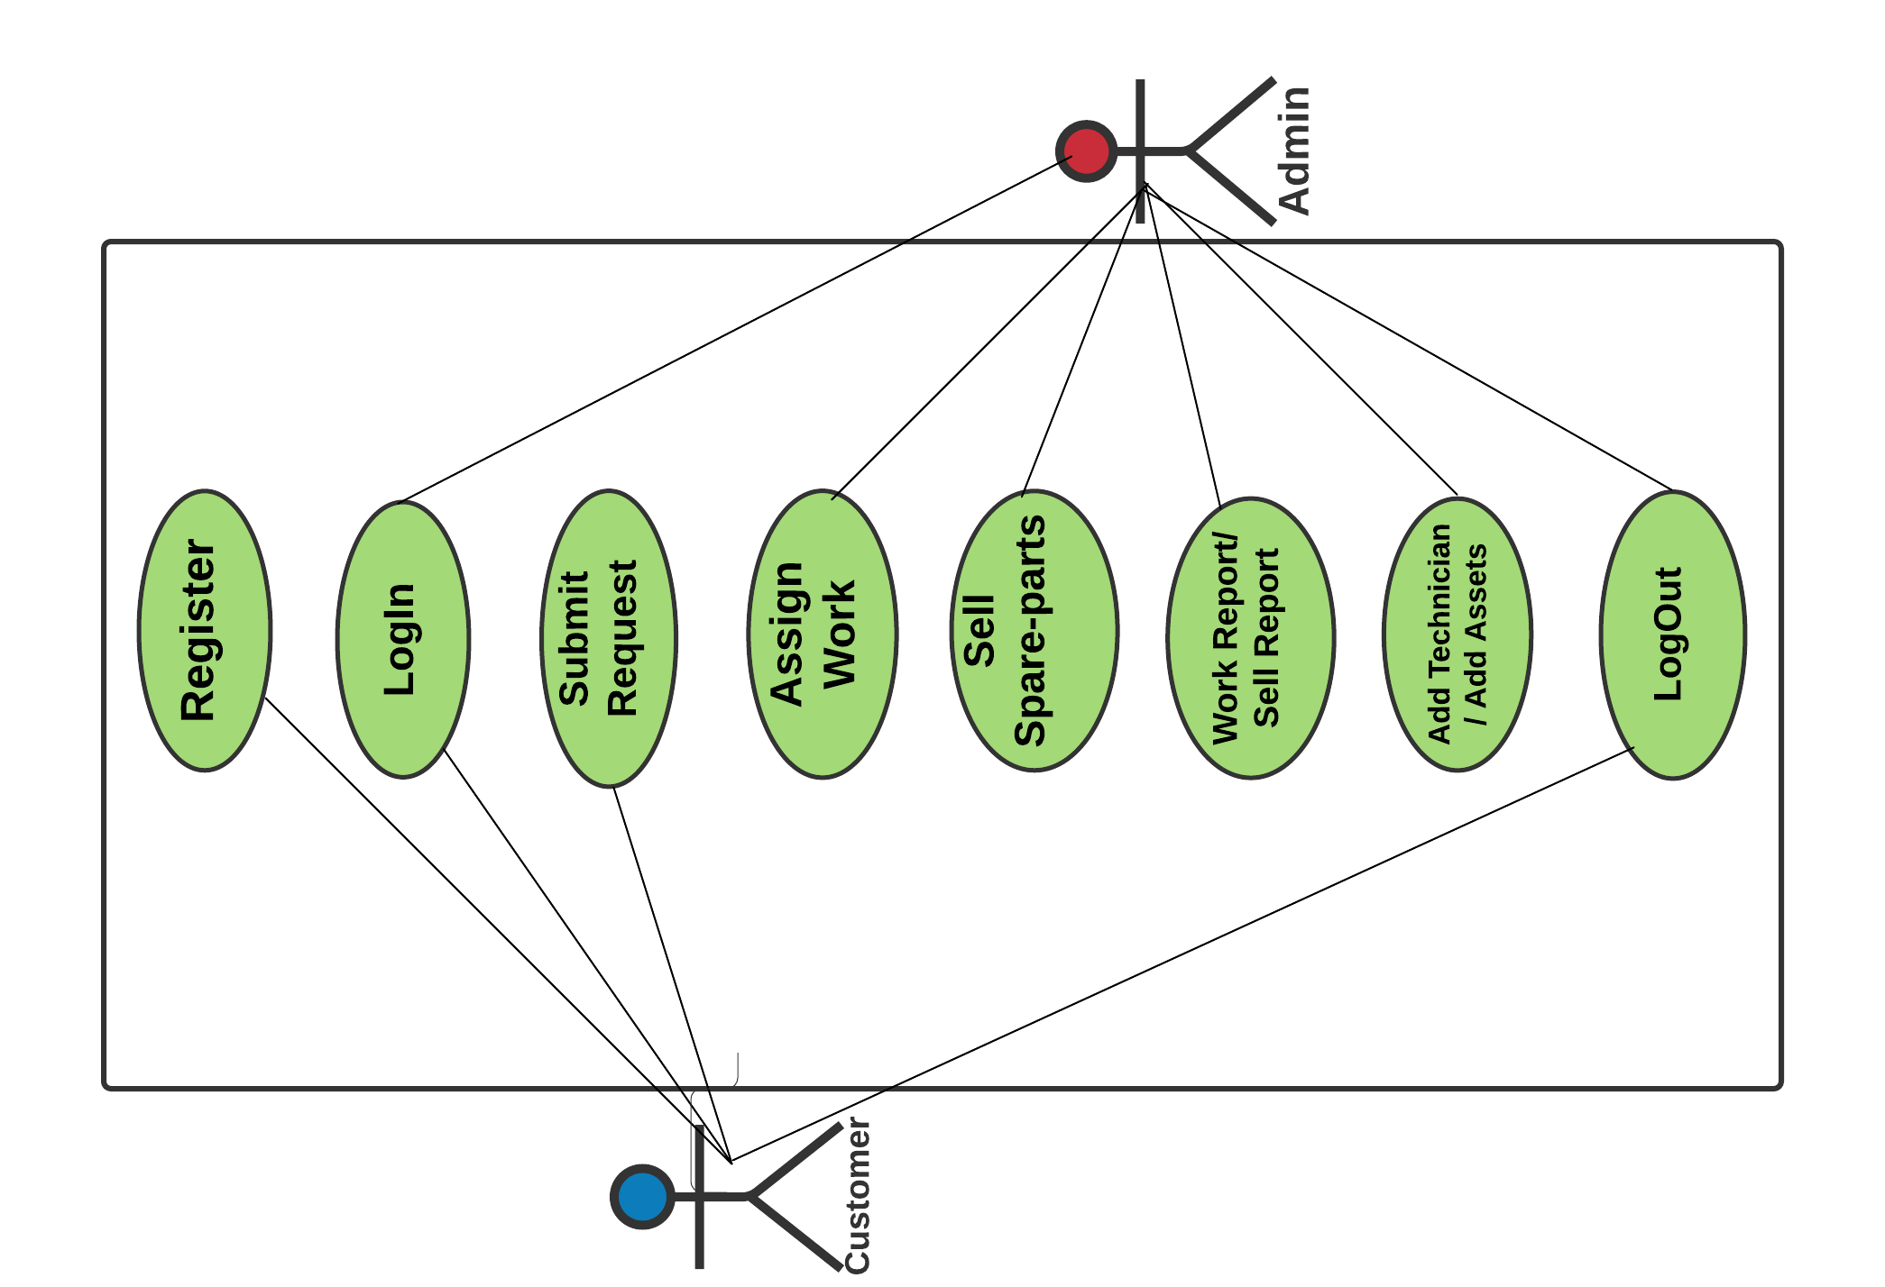

**Fig.3 : Use Case Diagram**

* 1. **Activity Flow Diagram**

A flowchart is a diagram that depicts a process, system or computer algorithm. They are widely used in multiple fields to document, study, plan, improve and communicate often complex processes in clear, easy-to-understand diagrams. Flowcharts, sometimes spelled as flow charts, use rectangles, ovals, diamonds and potentially numerous other shapes to define the type of step, along with connecting arrows to define flow and sequence.

**For Customer/Requester 🡪**

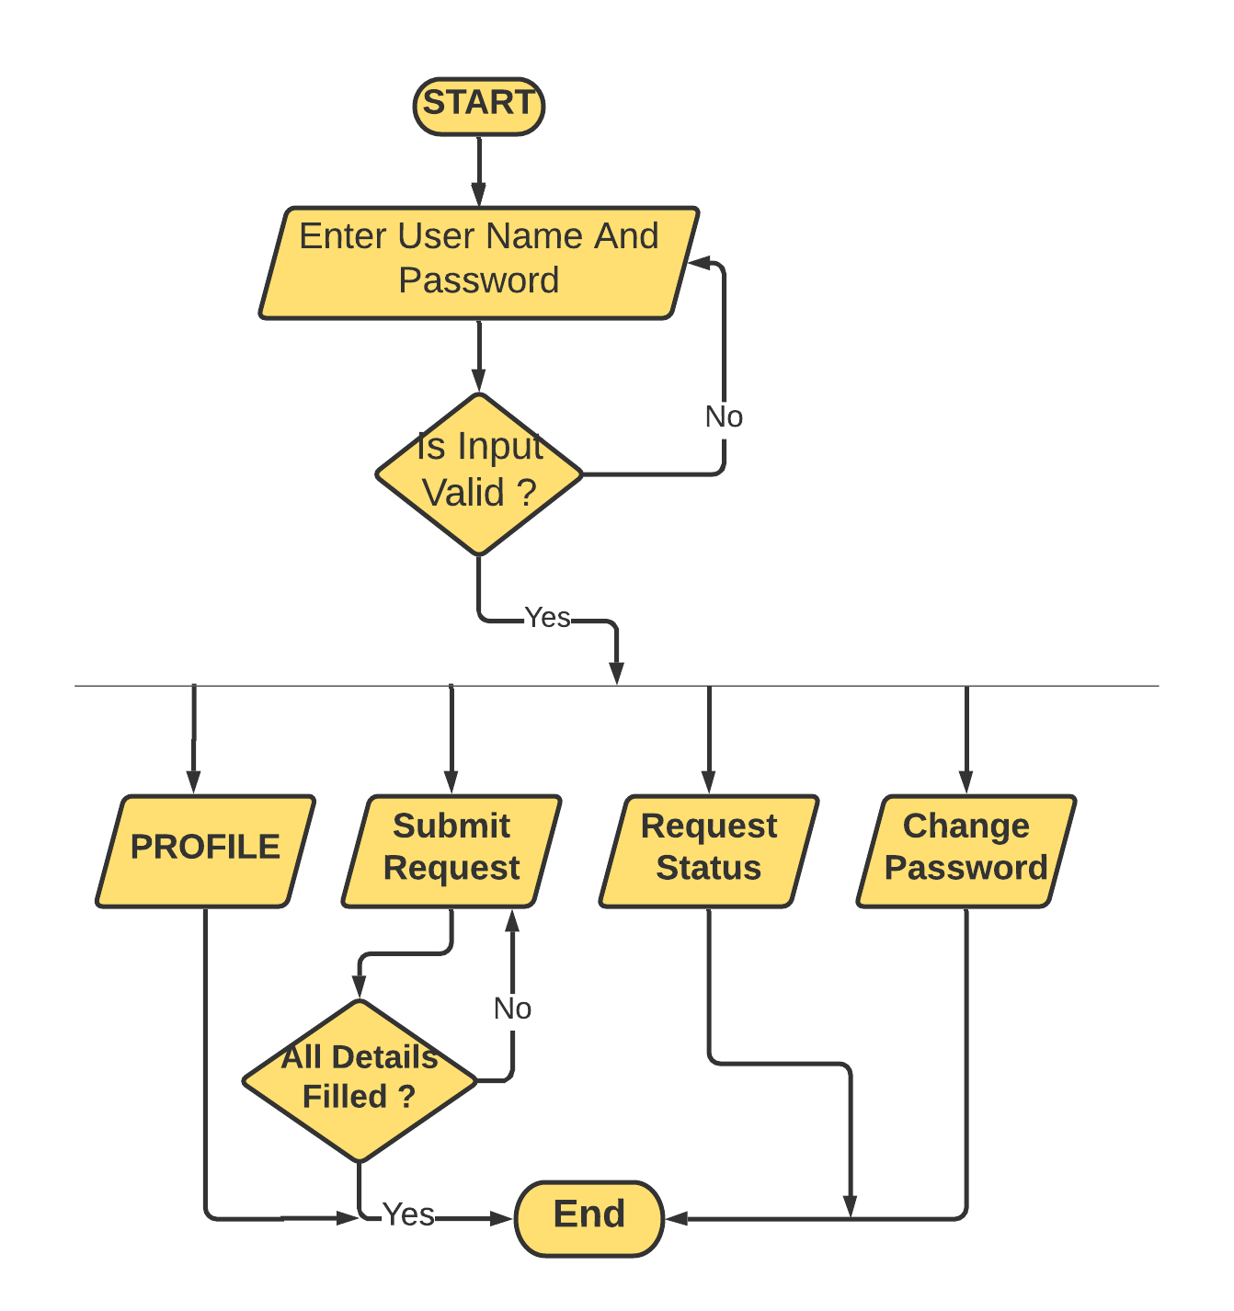

**Fig.4 : Activity Diagram-1**

**For Admin 🡪**

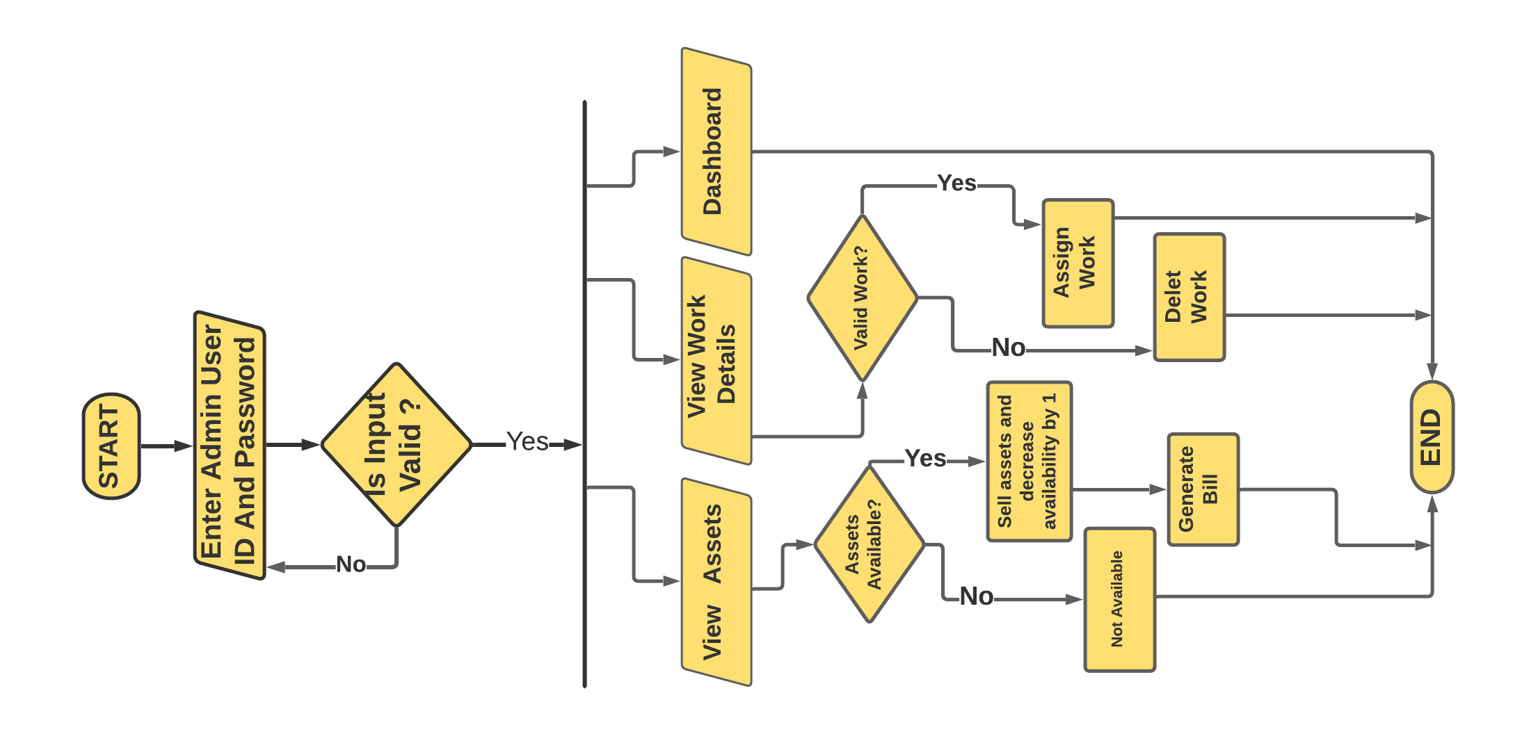

**Fig. 5: Activity Diagram-2**

* 1. **Class Diagram**

Class diagrams are the main building block in object-oriented modeling. They are used to show the different objects in a system, their attributes, their operations and the relationships among them.

Classes in class diagrams are represented by boxes that are partitioned into three:-

* The top partition contains the name of the class.
* The middle part contains the class’s attributes.
* The bottom partition shows the possible operations that are associated with the class.

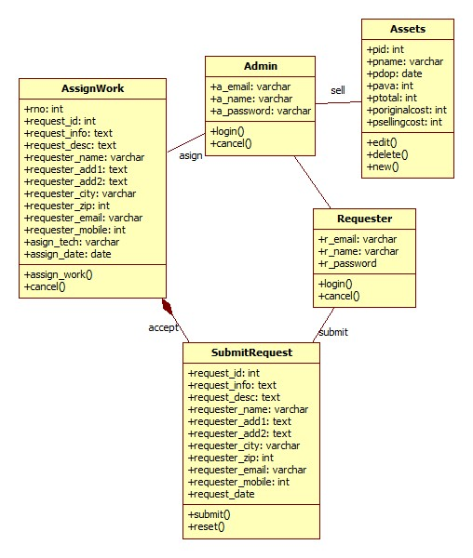

**Fig. 6: Class Diagram**

* 1. **Sequence Diagram**

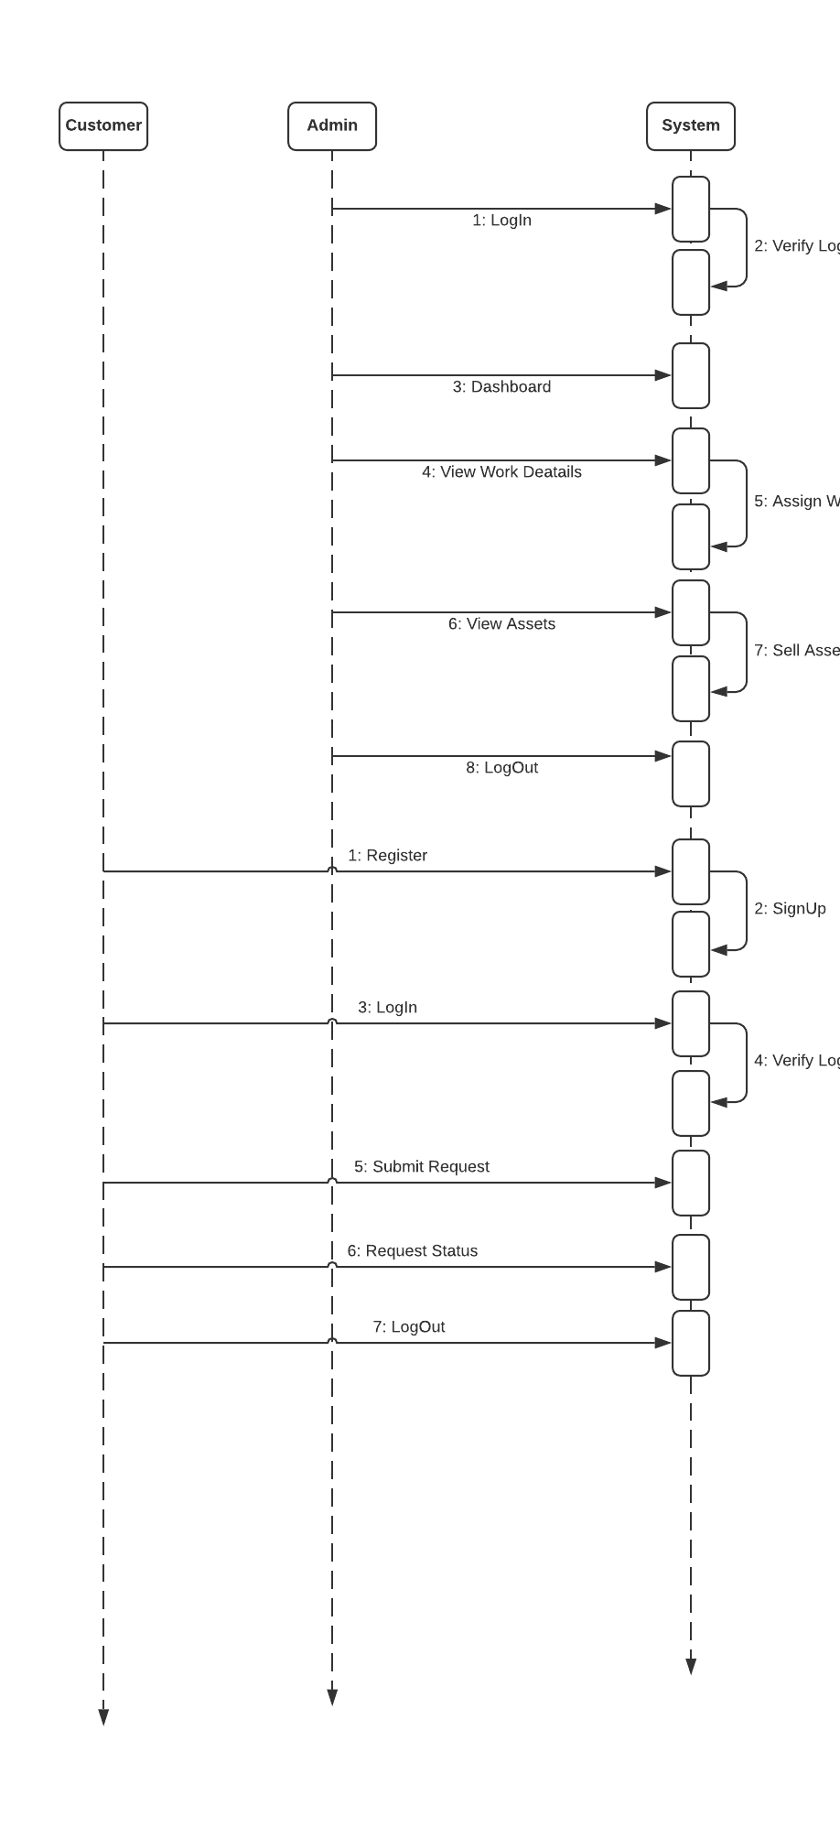

**Fig. 7 : Sequence Diagram**

* 1. **Data Flow Diagram**

Data flow diagram is graphical representation of flow of data in an information system. It uses defined symbols like rectangles, circles and arrows, plus short text labels, to show data inputs, outputs, storage points and the routes between each destination. Data flowcharts can range from simple, even hand-drawn process overviews, to in-depth, multi-level DFDs that dig progressively deeper into how the data is handled.

**5.5.1. DFD 0 Level**

The 0 Level DFD shows flow of data of application. DFD Level 0 is also called a Context Diagram. It’s a basic overview of the whole system or process being analyzed or modeled.

Requester

Admin

Report

Approval

Submit request

Check status

**Fig. 8: DFD**

**5.5.2. DFD 1 Level**

DFD Level 1 provides a more detailed breakout of pieces of the Context Level Diagram. This DFD describes main functions carried out by the system, as we break down the high-level process of the Context Diagram into its sub-processes.

retrieve

submit_request

update

View info

submit

update

update

view

retrieve

retrieve

retrieve

update

customer_tb

assignwork_tb

requester_tb

admin_tb/requ_tb

Admin

Authentic Status

Authentic Status

Authentic Status

Authentic Status

Authentic Status

Requester

Authentic Status

assets

**Fig. 8: DFD**

**5.5.3. DFD 2 Level**

The DFD 2 Level describes flow of data in more detail. DFD Level 2 goes one step deeper into parts of Level 1. It may require more text to reach the necessary level of detail about the system’s functioning.

Authentic Status

success

Add, Remove, Edit

Save data

assignwork

info

Authentic Status

Add, Remove, Edit

success

Save data

assets

info

**Fig. 8: DFD**

* 1. **Entity Relationship Diagram (ER-Diagram)**

An Entity Relationship Diagram (ERD) is a visual representation of different entities within a system and how they relate to each other. Entity relationship diagrams are used in software engineering during the planning stages of the software project. They help to identify different system elements and their relationships with each other.

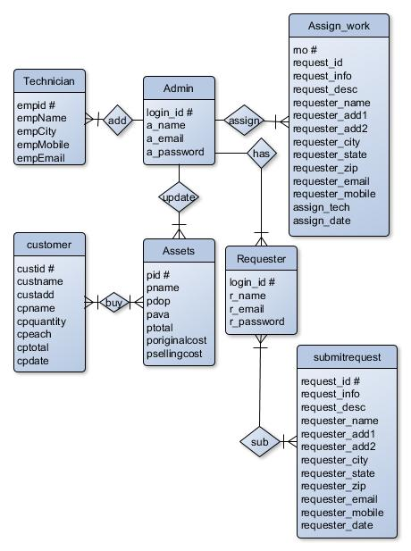

**Fig.9 : E-R Diagram**

**Chapter-6:: Coding /Code Templates**

**Index.php**

<?php

include 'C:\xampp\htdocs\maintain\DB.php';

?>

<!DOCTYPE html>

<html lang="en">

<head>

<meta charset="UTF-8">

<meta name="viewport" content="width=device-width, initial-scale=1.0">

<meta http-equiv="X-UA-Compatible" content="ie=edge">

<!-- Bootstrap CSS -->

<link rel="stylesheet" href="css/bootstrap.min.css">

<!-- Font Awesome CSS -->

<link rel="stylesheet" href="css/all.min.css">

<!-- Google Font -->

<link href="https://fonts.googleapis.com/css?family=Ubuntu&display=swap" rel="stylesheet">

<!-- Custom CSS -->

<link rel="stylesheet" href="css/custom.css">

<title>Your Technician</title>

</head>

<body>

<!-- Start Navigation -->

<nav class="navbar navbar-expand-sm navbar-dark bg-dark pl-5 fixed-top">

<a href="index.php" class="navbar-brand">Technician</a>

<button type="button" class="navbar-toggler" data-toggle="collapse" data-target="#myMenu">

<span class="navbar-toggler-icon"></span>

</button>

<div class="collapse navbar-collapse" id="myMenu">

<ul class="navbar-nav mr-auto pl-5 custom-nav">

<li class="nav-item"><a href="index.php" class="nav-link" style="font-weight:bold;">Home</a></li>

<li class="nav-item"><a href="#Services" class="nav-link" style="font-weight:bold;">Services</a></li>

<li class="nav-item"><a href="Requester/login.php" class="nav-link" style="font-weight:bold;">Register</a></li>

<li class="nav-item"><a href="Requester/login.php" class="nav-link" style="font-weight:bold;">LogIn</a></li>

<li class="nav-item"><a href="#Contact" class="nav-link" style="font-weight:bold;">Contact</a></li>

<li class="nav-item"><a href="Admin/admin_login.php" class="nav-link" style="font-weight:bold;">Admin</a></li>

</ul>

</div>

</nav> <!-- End Navigation -->

<!-- Start Header Jumbotron-->

<header class="jumbotron back-image" style="background-image:url(images/Banner.jpg);">

<div class="myclass mainHeading">

<label class="">

<!--badge badge-pill badge-info-->

<h1 class="text-uppercase font-weight-bold text-info" style="background-color:darkslategrey; border-radius:15px;">Welcome to Technician</h1>

</label>

<p class="font-italic text-danger font-weight-bold xyz">Customer's Happiness is our Aim</p>

<a href="Requester/login.php" class="btn btn-success mr-4">LogIn</a>

<a href="Requester/login.php" class="btn btn-danger mr-4">Sign Up</a>

</div>

</header> <!-- End Header Jumbotron-->

<!-- Start Introduction Section -->

<div class="container">

<div class="jumbotron">

<h1 class="text-center">Our Services</h1>

<p style="font-size:18px">

Our Maintenance Services is India’s leading chain of multi-brand Electronics and Electrical service workshops offering wide array of services. We focus on enhancing your uses experience by offering world-class Electronic Appliance's maintenance services. Our sole mission is “To provide Electronic Appliance's care services to keep the devices fit and healthy and customers happy and smiling”.

With well-equipped Electronic Appliances service centres and fully trained mechanics, we provide quality services with excellent packages that are designed to offer you great savings.

Our state-of-art workshops are conveniently located in many

cities across the country. Now you can book your service online by doing Registration.

</p>

</div>

</div> <!-- End Introduction Section Container -->

<!-- Start Services Section -->

<div class="container text-center border-bottom" id="Services">

<h1>We Provide</h1>

<div class="row mt-4">

<div class="col-sm-4 mb-4">

<a href="#"><i class="fas fa-tv fa-8x text-success"></i></a>

<h4 class="mt-4">Electronic Appliances</h4>

</div>

<div class="col-sm-4 mb-4">

<a href="#"><i class="fas fa-sliders-h fa-8x text-primary"></i></a>

<h4 class="mt-4">Preventive Maintenance</h4>

</div>

<div class="col-sm-4 mb-4">

<a href="#"><i class="fas fa-cogs fa-8x text-info"></i></a>

<h4 class="mt-4">Fault Repair</h4>

</div>

</div>

</div> <!-- End Services Section Container -->

<!-- Start Top Technicians -->

<div class="jumbotron bg-danger">

<div class="container">

<h1 class="text-center text-white">Top Technicians</h1>

<div class="row mt-5">

<div class="col-lg-3 col-sm-6">

<!-- Start 1st Column -->

<div class="card shadow-lg mb-2">

<div class="card-body text-center">

<img src="images/avtar1.jpeg" class="img-fluid" style="border-radius:100px;" alt="avt1">

<h4 class="card-title">Rahul Kumar</h4>

<p class="card-text">To refrigerate a clock was an extremely violent act, not one I could explain to anyone.</p>

</div>

</div>

</div> <!-- End 1st Column -->

<div class="col-lg-3 col-sm-6">

<!-- Start 2nd Column -->

<div class="card shadow-lg mb-2">

<div class="card-body text-center">

<img src="images/avtar2.jpeg" class="img-fluid" style="border-radius:100px;" alt="avt2">

<h4 class="card-title">Sonam Sharma</h4>

<p class="card-text">washing machine - if you don't look away quickly, you'll be watching until the end.</p>

</div>

</div>

</div> <!-- End 2nd Column -->

<div class="col-lg-3 col-sm-6">

<!-- Start 3rd Column -->

<div class="card shadow-lg mb-2">

<div class="card-body text-center">

<img src="images/avtar3.jpeg" class="img-fluid" style="border-radius:100px;" alt="avt3">

<h4 class="card-title">Sumit Vyas</h4>

<p class="card-text">Computers are counting human. It is a super Human that runs over electricity.</p>

</div>

</div>

</div> <!-- End 3rd Column -->

<div class="col-lg-3 col-sm-6">

<!-- Start 4th Column -->

<div class="card shadow-lg mb-2">

<div class="card-body text-center">

<img src="images/avtar4.jpeg" class="img-fluid" style="border-radius:100px;" alt="avt4">

<h4 class="card-title">Jyoti Sinha</h4>

<p class="card-text">Television is the menace that everyone loves to hate but can't seem to live without.</p>

</div>

</div>

</div> <!-- End 4th Column -->

</div>

</div>

</div> <!-- End Happy Customer -->

<!-- Start Contact US -->

<div class="container" id="Contact">

<h2 class="text-center mb-4">Contact Us</h2>

<div class="row">

<div class="col-md-6 text-center" style="font-size:20px;">

<strong>Headquarter:</strong><br>

Gupta pvt Ltd,<br>

Ashok Nagar, Ranchi<br>

Jharkhand - 434567<br>

Phone: +0000000000<br>

<a href="#" target="_blank">www.technician.com</a><br>

</div>

<div class="col-md-6 text-center" style="font-size:20px;">

<strong>Branch:</strong><br>

F1 solutions pvt Ltd,<br>

Saheed Nagar, Bhubaneswar<br>

Odisha - 751003<br>

Phone: +0123456789<br>

<a href="#" target="_blank">www.technician.com</a><br>

</div>

</div>

</div> <!-- End Contact US -->

<div class="container">

<div class="links">

<h2 class="text-center">Other Links</h2>

<a href="Admin/admin_login.php">Admin Login</a>

</div>

</div>

<!-- Start Footer -->

<footer class="container-fluid bg-dark mt-5 text-white">

<div class="container">

<div class="row py-3">

<div class="col-md-6">

<!-- Start 1st Column -->

<span class="pr-2">Follow Us: </span>

<a href="#" target="_blank" class="pr-2 fi-color"><i class="fab fa-facebook-f"></i></a>

<a href="#" target="_blank" class="pr-2 fi-color"><i class="fab fa-twitter"></i></a>

<a href="#" target="_blank" class="pr-2 fi-color"><i class="fab fa-youtube"></i></a>

<a href="#" target="_blank" class="pr-2 fi-color"><i class="fab fa-google-plus-g"></i></a>

<a href="#" target="_blank" class="pr-2 fi-color"><i class="fas fa-rss"></i></a>

</div> <!-- End 1st Column -->

<div class="col-md-6 text-right">

<!-- Start 2nd Column -->

<small>Designed by F1 Solutions&copy; 2020</small>

<small class="ml-2"><a href="Admin/admin_login.php">Admin Login</a></small>

</div> <!-- End 2nd Column -->

</div>

</div>

</footer>

<!-- JavaScript -->

<script src="js/jquery.min.js"></script>

<script src="js/popper.min.js"></script>

<script src="js/bootstrap.min.js"></script>

<script src="js/all.min.js"></script>

</body>

</html>

**custom.css**

body {

background: radial-gradient(circle, rgba(238, 174, 202, 1) 23%, rgba(148, 187, 233, 1) 100%);

}

/* Change Brand Name Font */

.navbar-brand {

font-family: "Ubuntu", sans-serif;

font-size: 2.5em;

font-weight: bold;

}

.nav-item {

font-size: 20px

}

/* Change Navigation color */

.navbar #myMenu .custom-nav .nav-item a {

color: #fff;

}

.navbar #myMenu .custom-nav .nav-item a:hover {

color: #f0aab1;

}

/* Make Header Image Responsive */

.back-image {

background-size: cover;

background-position: center center;

background-repeat: no-repeat;

min-height: 73vh;

border-radius: 0px;

margin-top: 30px;

}

/* Header Image Sub-Title */

.font-italic {

font-size: 24px;

}

.fi-color {

color: #dc3545;

}

.fi-color:hover {

color: #e994a2;

}

.links {

align-content: center;

align-items: center;

text-align: center;

}

a {

color: black;

}

.active {

color: white;

background-color: #dc3545;

}

a:hover {

color: #f26571;

}

.mainHeading {

margin-top: 50px;

}

.sidebar a:hover {

background-color: lightcyan;

}

@media only screen and (max-width: 600px) {

.myclass {

margin-top: 350px;

text-align: center;

}

.xyz {

background-color: darkslategrey;

border-radius: 15px;

}

}

**DB.php**

<?php

class DB{

private static function connect(){

$pdo = new PDO('mysql:host=127.0.0.1; dbname=maintain; charset=utf8mb4', 'root', '');

$pdo->setAttribute(PDO::ATTR_ERRMODE, PDO::ERRMODE_EXCEPTION);

return $pdo;

}

public static function query($query, $params = array()){

$statement = self::connect()->prepare($query);

$statement->execute($params);

if(explode(' ', $query)[0] == 'SELECT'){

$data = $statement->fetchAll();

return $data;

}

}

}

?>

**dbConnection.php**

<?php

$db_host = "localhost";

$db_user = "root";

$db_password = "";

$db_name = "maintain";

$db_port = 3306;

// Create Connection

$conn = new mysqli($db_host, $db_user, $db_password, $db_name, $db_port);

// Checking Connection

if($conn->connect_error){

die("Connection Failed");

}

// else {

// echo "Connect";

// }

?>

**For Customer 🡪**

**SignUp/LogIn Page :-**

**login.php**

<?php

require 'C:\xampp\htdocs\maintain\DB.php';

require 'core/load.php';

session_start();

if( isset($_POST['full-name']) && !empty($_POST['full-name'])){

$upName = $_POST['full-name'];

$upEmailMobile = $_POST['email-mobile'];

$upPassword = $_POST['up-password'];

if(empty($upName) or empty($upEmailMobile) or empty($upPassword)){

$error = '*All fields are required';

}else{

$full_name = $loadFromUser->checkInput($upName);

$email_mobile = $loadFromUser->checkInput($upEmailMobile);

$password = $loadFromUser->checkInput($upPassword);

$screenName = $full_name;

if(DB::query('SELECT screenName FROM c_login WHERE screenName = :screenName', array(':screenName' => $screenName ))){

$screenRand = rand();

$userLink = ''.$screenName.''.$screenRand.'';

}else{

$userLink = $screenName;

}

if(!preg_match("^[_a-z0-9-]+(\.[_a-z0-9]+)*@[a-z0-9-]+(\.[a-z0-9-]+)*(\.[a-z]{2,3})$^",$email_mobile)){

if(!preg_match("^[0-9]{10}^", $email_mobile)){

$error = '*Email or Mobile is not correct.';

}else{

$mob = strlen((string)$email_mobile);

if($mob > 10 || $mob < 10){

$error = '*Mobile number is not valid';

}else if(strlen($password) <8 || strlen($password) >= 15){

$error = '*Password must be between 8-15 characters.';

}else{

if(DB::query('SELECT mobile FROM c_login WHERE mobile=:mobile', array(':mobile'=>$email_mobile))){

$error = '*This Mobile is already in use.';

}else{

$user_id=$loadFromUser->create('c_login', array('full_name'=>$full_name, 'mobile' => $email_mobile, 'password'=>password_hash($password, PASSWORD_BCRYPT),'screenName'=>$screenName,'userLink'=>$userLink));

/*$loadFromUser->create('profile', array('userId'=>$user_id, 'birthday'=> $birth, 'firstName' => $first_name, 'lastName'=>$last_name, 'regNo'=>$reg_no, 'profilePic'=>'assets/image/defaultProfile.png','coverPic'=>'assets/image/defaultCover.png', 'gender'=>$upgen));

$tstrong = true;

$token = bin2hex(openssl_random_pseudo_bytes(64, $tstrong));

$loadFromUser->create('token', array('token'=>sha1($token), 'user_id'=>$user_id));

setcookie('FBID', $token, time()+60*60*24*7, '/', NULL, NULL, true);*/

$_SESSION['email-mobile'] = $email_mobile;

$_SESSION['full_name'] = $full_name;

header('Location: RequesterProfile.php');

}

}

}

}else{

if(!filter_var($email_mobile)){

$error = "*Invalid Email Format";

}else if(strlen($full_name) > 50){

$error = "*Name must be between 5-50 character";

}else if(strlen($password) <8 && strlen($password) >= 15){

$error = "*Password must be between 8-15 characters.";

}else{

if((filter_var($email_mobile,FILTER_VALIDATE_EMAIL)) && $loadFromUser->checkEmail($email_mobile) === true){

$error = "*Email is already in use";

}else{

$user_id = $loadFromUser->create('c_login', array('full_name'=>$full_name, 'email' => $email_mobile, 'password'=>password_hash($password, PASSWORD_BCRYPT),'screenName'=>$screenName,'userLink'=>$userLink));

/*$loadFromUser->create('profile', array('userId'=>$user_id, 'birthday'=>$birth, 'firstName' => $first_name, 'lastName'=>$last_name, 'regNo'=>$reg_no, 'profilePic'=>'assets/image/defaultProfile.png','coverPic'=>'assets/image/defaultCover.png', 'gender'=>$upgen));

$tstrong = true;

$token = bin2hex(openssl_random_pseudo_bytes(64, $tstrong));

$loadFromUser->create('token', array('token'=>sha1($token), 'user_id'=>$user_id));

setcookie('FBID', $token, time()+60*60*24*7, '/', NULL, NULL, true);*/

$_SESSION['email-mobile'] = $email_mobile;

$_SESSION['full_name'] = $full_name;

header('Location: RequesterProfile.php');

}

}

}

}

}

if(isset($_POST['in-email-mobile']) && !empty($_POST['in-email-mobile'])){

$email_mobile = $_POST['in-email-mobile'];

$in_pass = $_POST['in-pass'];

if(!preg_match("^[_a-z0-9-]+(\.[_a-z0-9]+)*@[a-z0-9-]+(\.[a-z0-9-]+)*(\.[a-z]{2,3})$^", $email_mobile)){

if(!preg_match("^[0-9]{10}^", $email_mobile)){

$error1 = '*Email or Phone is not correct.';

}else{

if(DB::query("SELECT mobile FROM c_login WHERE mobile = :mobile", array(':mobile'=>$email_mobile))){

if(password_verify($in_pass, DB::query('SELECT password FROM c_login WHERE mobile=:mobile', array(':mobile'=>$email_mobile))[0]['password'])){

$user_id=DB::query('SELECT user_id FROM c_login WHERE mobile=:mobile', array(':mobile'=>$email_mobile))[0]['user_id'];

/*$tstrong = true;

$token = bin2hex(openssl_random_pseudo_bytes(64, $tstrong));

$loadFromUser->create('token', array('token'=>sha1($token), 'user_id'=>$user_id));

setcookie('FBID', $token, time()+60*60*24*7, '/', NULL, NULL, true);*/

$full_name=DB::query('SELECT full_name FROM c_login WHERE mobile=:mobile', array(':mobile'=>$email_mobile))[0]['full_name'];

$_SESSION['email-mobile'] = $email_mobile;

$_SESSION['full_name'] = $full_name;

header('Location: RequesterProfile.php');

}else{

$error1="*Password is not correct";

}

}else{

$error1="*User hasn't found.";

}

}

}else{

if(DB::query("SELECT email FROM c_login WHERE email = :email", array(':email'=>$email_mobile))){

if(password_verify($in_pass, DB::query('SELECT password FROM c_login WHERE email=:email', array(':email'=>$email_mobile))[0]['password'])){

$user_id=DB::query('SELECT user_id FROM c_login WHERE email=:email', array(':email'=>$email_mobile))[0]['user_id'];

/*$tstrong = true;

$token = bin2hex(openssl_random_pseudo_bytes(64, $tstrong));

$loadFromUser->create('token', array('token'=>sha1($token), 'user_id'=>$user_id));

setcookie('FBID', $token, time()+60*60*24*7, '/', NULL, NULL, true);*/

$full_name=DB::query('SELECT full_name FROM c_login WHERE email=:email', array(':email'=>$email_mobile))[0]['full_name'];

$_SESSION['email-mobile'] = $email_mobile;

$_SESSION['full_name'] = $full_name;

header('Location: RequesterProfile.php');

}else{

$error1="*Password is not correct";

}

}else{

$error1="*User hasn't found.";

}

}

}

?>

<!DOCTYPE html>

<html lang="en">

<head>

<meta charset="UTF-8" />

<meta name="viewport" content="width=device-width, initial-scale=1.0" />

<link rel="stylesheet" href="css/login.css" />

<title>LogIn Form</title>

</head>

<body>

<div class="container">

<div class="forms-container">

<div class="signin-signup">

<div class="error" style="float:right; color:red; margin-left:50px; font-weight:bold; font-size: 20px;">

<?php if(!empty($error1)){echo $error1;} ?>

</div>

<form action="login.php" method="post" class="sign-in-form">

<h2 class="title">Coustmer Sign in</h2>

<div class="input-field">

<i class="fas fa-user"></i>

<input type="text" name="in-email-mobile" placeholder="Email Or Mobile" />

</div>

<div class="input-field">

<i class="fas fa-lock"></i>

<input type="password" name="in-pass" placeholder="Password" />

</div>

<input type="submit" value="Login" class="btn solid" />

</form>

<div class="error" style="float:right; color:red; margin-left:50px; font-weight:bold; font-size: 20px;">

<?php if(!empty($error)){echo $error;} ?>

</div>

<form action="login.php" method="post" class="sign-up-form">

<h2 class="title">Coustmer Sign up</h2>

<div class="input-field">

<i class="fas fa-user"></i>

<input type="text" name="full-name" placeholder="Full Name" />

</div>

<div class="input-field">

<i class="fas fa-envelope"></i>

<input type="text" name="email-mobile" placeholder="Email Or Mobile" />

</div>

<div class="input-field">

<i class="fas fa-lock"></i>

<input type="password" name="up-password" placeholder="Password" />

</div>

<input type="submit" class="btn" value="Sign up" />

</form>

</div>

</div>

<div class="panels-container">

<div class="panel left-panel">

<div class="content">

<h3>New here ?</h3>

<p>

Register with us. And enjoy all our services.

</p>

<button class="btn transparent" id="sign-up-btn">

Sign up

</button>

</div>

<img src="img/log.svg" class="image" alt="" />

</div>

<div class="panel right-panel">

<div class="content">

<h3>One of us ?</h3>

<p>

Sign in with Us. And Enjoy all our services.

</p>

<button class="btn transparent" id="sign-in-btn">

Sign in

</button>

</div>

<img src="img/register.svg" class="image" alt="" />

</div>

</div>

</div>

<script src="js/app.js"></script>

</body>

</html>

**header.php**

<?php

require 'C:\xampp\htdocs\maintain\DB.php';

require 'core/load.php';

session_start();

if( isset($_POST['full-name']) && !empty($_POST['full-name'])){

$upName = $_POST['full-name'];

$upEmailMobile = $_POST['email-mobile'];

$upPassword = $_POST['up-password'];

if(empty($upName) or empty($upEmailMobile) or empty($upPassword)){

$error = '*All fields are required';

}else{

$full_name = $loadFromUser->checkInput($upName);

$email_mobile = $loadFromUser->checkInput($upEmailMobile);

$password = $loadFromUser->checkInput($upPassword);

$screenName = $full_name;

if(DB::query('SELECT screenName FROM c_login WHERE screenName = :screenName', array(':screenName' => $screenName ))){

$screenRand = rand();

$userLink = ''.$screenName.''.$screenRand.'';

}else{

$userLink = $screenName;

}

if(!preg_match("^[_a-z0-9-]+(\.[_a-z0-9]+)*@[a-z0-9-]+(\.[a-z0-9-]+)*(\.[a-z]{2,3})$^",$email_mobile)){

if(!preg_match("^[0-9]{10}^", $email_mobile)){

$error = '*Email or Mobile is not correct.';

}else{

$mob = strlen((string)$email_mobile);

if($mob > 10 || $mob < 10){

$error = '*Mobile number is not valid';

}else if(strlen($password) <8 || strlen($password) >= 15){

$error = '*Password must be between 8-15 characters.';

}else{

if(DB::query('SELECT mobile FROM c_login WHERE mobile=:mobile', array(':mobile'=>$email_mobile))){

$error = '*This Mobile is already in use.';

}else{

$user_id=$loadFromUser->create('c_login', array('full_name'=>$full_name, 'mobile' => $email_mobile, 'password'=>password_hash($password, PASSWORD_BCRYPT),'screenName'=>$screenName,'userLink'=>$userLink));

/*$loadFromUser->create('profile', array('userId'=>$user_id, 'birthday'=> $birth, 'firstName' => $first_name, 'lastName'=>$last_name, 'regNo'=>$reg_no, 'profilePic'=>'assets/image/defaultProfile.png','coverPic'=>'assets/image/defaultCover.png', 'gender'=>$upgen));

$tstrong = true;

$token = bin2hex(openssl_random_pseudo_bytes(64, $tstrong));

$loadFromUser->create('token', array('token'=>sha1($token), 'user_id'=>$user_id));

setcookie('FBID', $token, time()+60*60*24*7, '/', NULL, NULL, true);*/

$_SESSION['email-mobile'] = $email_mobile;

$_SESSION['full_name'] = $full_name;

header('Location: RequesterProfile.php');

}

}

}

}else{

if(!filter_var($email_mobile)){

$error = "*Invalid Email Format";

}else if(strlen($full_name) > 50){

$error = "*Name must be between 5-50 character";

}else if(strlen($password) <8 && strlen($password) >= 15){

$error = "*Password must be between 8-15 characters.";

}else{

if((filter_var($email_mobile,FILTER_VALIDATE_EMAIL)) && $loadFromUser->checkEmail($email_mobile) === true){

$error = "*Email is already in use";

}else{

$user_id = $loadFromUser->create('c_login', array('full_name'=>$full_name, 'email' => $email_mobile, 'password'=>password_hash($password, PASSWORD_BCRYPT),'screenName'=>$screenName,'userLink'=>$userLink));

/*$loadFromUser->create('profile', array('userId'=>$user_id, 'birthday'=>$birth, 'firstName' => $first_name, 'lastName'=>$last_name, 'regNo'=>$reg_no, 'profilePic'=>'assets/image/defaultProfile.png','coverPic'=>'assets/image/defaultCover.png', 'gender'=>$upgen));

$tstrong = true;

$token = bin2hex(openssl_random_pseudo_bytes(64, $tstrong));

$loadFromUser->create('token', array('token'=>sha1($token), 'user_id'=>$user_id));

setcookie('FBID', $token, time()+60*60*24*7, '/', NULL, NULL, true);*/

$_SESSION['email-mobile'] = $email_mobile;

$_SESSION['full_name'] = $full_name;

header('Location: RequesterProfile.php');

}

}

}

}

}

if(isset($_POST['in-email-mobile']) && !empty($_POST['in-email-mobile'])){

$email_mobile = $_POST['in-email-mobile'];

$in_pass = $_POST['in-pass'];

if(!preg_match("^[_a-z0-9-]+(\.[_a-z0-9]+)*@[a-z0-9-]+(\.[a-z0-9-]+)*(\.[a-z]{2,3})$^", $email_mobile)){

if(!preg_match("^[0-9]{10}^", $email_mobile)){

$error1 = '*Email or Phone is not correct.';

}else{

if(DB::query("SELECT mobile FROM c_login WHERE mobile = :mobile", array(':mobile'=>$email_mobile))){

if(password_verify($in_pass, DB::query('SELECT password FROM c_login WHERE mobile=:mobile', array(':mobile'=>$email_mobile))[0]['password'])){

$user_id=DB::query('SELECT user_id FROM c_login WHERE mobile=:mobile', array(':mobile'=>$email_mobile))[0]['user_id'];

/*$tstrong = true;

$token = bin2hex(openssl_random_pseudo_bytes(64, $tstrong));

$loadFromUser->create('token', array('token'=>sha1($token), 'user_id'=>$user_id));

setcookie('FBID', $token, time()+60*60*24*7, '/', NULL, NULL, true);*/

$full_name=DB::query('SELECT full_name FROM c_login WHERE mobile=:mobile', array(':mobile'=>$email_mobile))[0]['full_name'];

$_SESSION['email-mobile'] = $email_mobile;

$_SESSION['full_name'] = $full_name;

header('Location: RequesterProfile.php');

}else{

$error1="*Password is not correct";

}

}else{

$error1="*User hasn't found.";

}

}

}else{

if(DB::query("SELECT email FROM c_login WHERE email = :email", array(':email'=>$email_mobile))){

if(password_verify($in_pass, DB::query('SELECT password FROM c_login WHERE email=:email', array(':email'=>$email_mobile))[0]['password'])){

$user_id=DB::query('SELECT user_id FROM c_login WHERE email=:email', array(':email'=>$email_mobile))[0]['user_id'];

/*$tstrong = true;

$token = bin2hex(openssl_random_pseudo_bytes(64, $tstrong));

$loadFromUser->create('token', array('token'=>sha1($token), 'user_id'=>$user_id));

setcookie('FBID', $token, time()+60*60*24*7, '/', NULL, NULL, true);*/

$full_name=DB::query('SELECT full_name FROM c_login WHERE email=:email', array(':email'=>$email_mobile))[0]['full_name'];

$_SESSION['email-mobile'] = $email_mobile;

$_SESSION['full_name'] = $full_name;

header('Location: RequesterProfile.php');

}else{

$error1="*Password is not correct";

}

}else{

$error1="*User hasn't found.";

}

}

}

?>

<!DOCTYPE html>

<html lang="en">

<head>

<meta charset="UTF-8" />

<meta name="viewport" content="width=device-width, initial-scale=1.0" />

<link rel="stylesheet" href="css/login.css" />

<title>LogIn Form</title>

</head>

<body>

<div class="container">

<div class="forms-container">

<div class="signin-signup">

<div class="error" style="float:right; color:red; margin-left:50px; font-weight:bold; font-size: 20px;">

<?php if(!empty($error1)){echo $error1;} ?>

</div>

<form action="login.php" method="post" class="sign-in-form">

<h2 class="title">Coustmer Sign in</h2>

<div class="input-field">

<i class="fas fa-user"></i>

<input type="text" name="in-email-mobile" placeholder="Email Or Mobile" />

</div>

<div class="input-field">

<i class="fas fa-lock"></i>

<input type="password" name="in-pass" placeholder="Password" />

</div>

<input type="submit" value="Login" class="btn solid" />

</form>

<div class="error" style="float:right; color:red; margin-left:50px; font-weight:bold; font-size: 20px;">

<?php if(!empty($error)){echo $error;} ?>

</div>

<form action="login.php" method="post" class="sign-up-form">

<h2 class="title">Coustmer Sign up</h2>

<div class="input-field">

<i class="fas fa-user"></i>

<input type="text" name="full-name" placeholder="Full Name" />

</div>

<div class="input-field">

<i class="fas fa-envelope"></i>

<input type="text" name="email-mobile" placeholder="Email Or Mobile" />

</div>

<div class="input-field">

<i class="fas fa-lock"></i>

<input type="password" name="up-password" placeholder="Password" />

</div>

<input type="submit" class="btn" value="Sign up" />

</form>

</div>

</div>

<div class="panels-container">

<div class="panel left-panel">

<div class="content">

<h3>New here ?</h3>

<p>

Register with us. And enjoy all our services.

</p>

<button class="btn transparent" id="sign-up-btn">

Sign up

</button>

</div>

<img src="img/log.svg" class="image" alt="" />

</div>

<div class="panel right-panel">

<div class="content">

<h3>One of us ?</h3>

<p>

Sign in with Us. And Enjoy all our services.

</p>

<button class="btn transparent" id="sign-in-btn">

Sign in

</button>

</div>

<img src="img/register.svg" class="image" alt="" />

</div>

</div>

</div>

<script src="js/app.js"></script>

</body>

</html>

**footer.php**

</div>

</div>

<script src="../js/jquery.min.js"></script>

<script src="../js/popper.min.js"></script>

<script src="../js/bootstrap.min.js"></script>

<script src="../js/all.min.js"></script>

</body>

</html>

**RequesterProfile.php**

<?php

define('TITLE', 'Requester Profile');

define('PAGE', 'RequesterProfile');

include('includes/header.php');

include('../dbConnection.php');

session_start();

$email_mobile=$_SESSION['email-mobile'];

if(isset($_REQUEST['nameupdate'])){

if($_REQUEST['full_Name'] == ""){

$error="*Fill The Box with Correct Details.";

}else{

$rName=$_REQUEST['full_Name'];

$sql="UPDATE c_login SET full_name= '$rName' WHERE email='$email_mobile' OR mobile='$email_mobile'";

if($conn->query($sql) == TRUE){

$error='<div class="alert alert-info mt-4" style="font-weight:bold; font-size:20px;">Data Updated Successfully.<br>You Need to logout and login again to show the Updated Name.</div>';

}

}

}

?>

<div class="col-sm-6 mt-5">

<form action="" method="post" class="mx-5">

<div class="form-group">

<label for="email-mobile">Your Email Or Mobile</label><input type="text" class="form-control" name="email-mobile" id="email-mobile" value="<?php echo $email_mobile; ?>" readonly>

</div>

<div class="form-group">

<label for="full_name">Full Name</label><input type="text" class="form-control" name="full_Name" id="full_name" value="<?php echo $_SESSION['full_name'] ?>">

</div>

<button type="submit" class="btn btn-danger" name="nameupdate">Update</button>

<div class="" style="color:red;">

<?php if(!empty($error)){echo $error;} ?>

</div>

</form>

</div>

<?php

include('includes/footer.php');

?>

**SubmitRequest.php**

<?php

define('TITLE', 'Submit Request');

define('PAGE', 'SubmitRequest');

include('includes/header.php');

include('../dbConnection.php');

session_start();

$email_mobile=$_SESSION['email-mobile'];

if(isset($_REQUEST['submitrequest'])){

// Checking for empty fields

if(($_REQUEST['electronicstype'] == "") || ($_REQUEST['requestinfo'] == "") || ($_REQUEST['requestdesc'] == "") || ($_REQUEST['requestername'] == "") || ($_REQUEST['requesteradd1'] == "") || ($_REQUEST['requesteradd2'] == "") || ($_REQUEST['requestercity'] == "") || ($_REQUEST['requesterstate'] == "") || ($_REQUEST['requesterzip'] == "") || ($_REQUEST['requesteremail'] == "") || ($_REQUEST['requestermobile'] == "") || ($_REQUEST['requestdate'] == "")){

$msg = "<div class='alert alert-warning col-sm-6 ml-5 mt-2' style='font-weight:bold; font-size:20px;'>Fill All Fields Clearly!</div>";

} else {

$rtype = $_REQUEST['electronicstype'];

$rinfo = $_REQUEST['requestinfo'];

$rdesc = $_REQUEST['requestdesc'];

$rname = $_REQUEST['requestername'];

$radd1 = $_REQUEST['requesteradd1'];

$radd2 = $_REQUEST['requesteradd2'];

$rcity = $_REQUEST['requestercity'];

$rstate = $_REQUEST['requesterstate'];

$rzip = $_REQUEST['requesterzip'];

$remail = $_REQUEST['requesteremail'];

$rmobile = $_REQUEST['requestermobile'];

$rdate = $_REQUEST['requestdate'];

$sql = "INSERT INTO submitrequest_tb(electronics_type,request_info, request_desc, requester_name, requester_add1,requester_add2,requester_city,requester_state,requester_zip,requester_email,requester_mobile,request_date)VALUES('$rtype','$rinfo','$rdesc','$rname','$radd1','$radd2','$rcity','$rstate', '$rzip','$remail','$rmobile','$rdate')";

if($conn->query($sql) == TRUE){

$genid = mysqli_insert_id($conn);

$msg = '<div class="alert alert-success col-sm-6 ml-5 mt-2" style="font-weight:bold; font-size:20px;">Request Submitted Sucessfully !</div>';

$_SESSION['myid'] = $genid;

echo "<script> location.href='submitrequestsuccess.php'</script>";

}else {

$msg = '<div class="alert alert-danger col-sm-6 ml-5 mt-2" style="font-weight:bold; font-size:20px;">Unable to Submit Your Request !</div>';

}

}

}

?>

<div class="col-sm-9 col-md-10 mt-5">

<!-- Start Service Request Form 2nd Column -->

<form class="mx-5" action="" method="post">

<div class="form-row">

<div class="form-group col-md-6">

<label for="inputGroupSelect1">Electronics Type</label>

<select class="custom-select" id="inputGroupSelect1" name="electronicstype">

<option selected></option>

<option value="Mobile and Accessories">1- Mobile and Accessories</option>

<option value="Computor and Accessories">2- Computor and Accessories</option>

<option value="Television and Accessories">3- Television and Accessories</option>

<option value="Home Appliances">4- Home Appliances</option>

<option value="Kitchen Appliances">5- Kitchen Appliances</option>

<option value="Washing Appliances">6- Washing Appliances</option>

<option value="Others">7- Others</option>

</select>

</div>

<div class="form-group col-md-6">

<label for="inputRequestInfo">Problem Info</label>

<input type="text" class="form-control" id="inputRequestInfo" placeholder="information or Topic of your Problem" name="requestinfo">

</div>

</div>

<div class="form-row">

<div class="form-group col-md-6">

<label for="inputRequestDescription">Description</label>

<textarea class="form-control" id="inputRequestDescription" name="requestdesc" placeholder="Write The Complete Description Of Your Problem"></textarea>

</div>

<div class="form-group col-md-6">

<label for="inputName">Name</label>

<input type="text" class="form-control" id="inputName" placeholder="Full Name" name="requestername">

</div>

</div>

<div class="form-row">

<div class="form-group col-md-6">

<label for="inputAddress">Address Line 1</label>

<input type="text" class="form-control" id="inputAddress" placeholder="House No./At/Post/Dist" name="requesteradd1">

</div>

<div class="form-group col-md-6">

<label for="inputAddress2">Address Line 2</label>

<input type="text" class="form-control" id="inputAddress2" placeholder="Landmark" name="requesteradd2">

</div>

</div>

<div class="form-row">

<div class="form-group col-md-6">

<label for="inputCity">City</label>

<input type="text" class="form-control" id="inputCity" name="requestercity">

</div>

<div class="form-group col-md-4">

<label for="inputState">State</label>

<input type="text" class="form-control" id="inputState" name="requesterstate">

</div>

<div class="form-group col-md-2">

<label for="inputZip">Zip</label>

<input type="text" class="form-control" id="inputZip" name="requesterzip" onkeypress="isInputNumber(event)">

</div>

</div>

<div class="form-row">

<div class="form-group col-md-6">

<label for="inputEmail">Email</label>

<input type="email" class="form-control" id="inputEmail" name="requesteremail">

</div>

<div class="form-group col-md-2">

<label for="inputMobile">Mobile</label>

<input type="text" class="form-control" id="inputMobile" name="requestermobile" onkeypress="isInputNumber(event)">

</div>

<div class="form-group col-md-2">

<label for="inputDate">Date</label>

<input type="date" class="form-control" id="inputDate" name="requestdate">

</div>

</div>

<button type="submit" class="btn btn-danger" name="submitrequest">Submit</button>

<button type="reset" class="btn btn-secondary">Reset</button>

</form>

<?php if(isset($msg)){echo $msg;} ?>

</div> <!-- End Service Request Form 2nd Column -->

<!-- Only Number for Input Fields -->

<script>

function isInputNumber(evt) {

var ch = String.fromCharCode(evt.which);

if (!(/[0-9]/.test(ch))) {

evt.preventDefault();

}

}

</script>

<?php

include('includes/footer.php');

?>

**Submitrequestsuccess.php**

<?php

define('TITLE', 'Success');

include('includes/header.php');

include('../dbConnection.php');

session_start();

$sql = "SELECT * FROM submitrequest_tb WHERE request_id ={$_SESSION['myid']}";

$result = $conn->query($sql);

if($result->num_rows == 1){

$row = $result->fetch_assoc();

echo "<div class='ml-5 mt-5' style='font-size:20px;'>

<table class='table'>

<tbody>

<tr>

<th>Request ID</th>

<td>".$row['request_id']."</td>

</tr>

<tr>

<th>Name</th>

<td>".$row['requester_name']."</td>

</tr>

<tr>

<th>Email ID</th>

<td>".$row['requester_email']."</td>

</tr>

<tr>

<th>Request Info</th>

<td>".$row['request_info']."</td>

</tr>

<tr>

<th>Request Description</th>

<td>".$row['request_desc']."</td>

</tr>

<tr>

<td><form class='d-print-none'><input class='btn btn-danger' type='submit' value='Print' onClick='window.print()'></form></td>

</tr>

</tbody>

</table> </div>

";

} else {

echo "Failed";

}

include('includes/footer.php');

?>

**CheckStatus.php**

<?php

define('TITLE', 'Status');

define('PAGE', 'CheckStatus');

include('includes/header.php');

include('../dbConnection.php');

session_start();

$email_mobile=$_SESSION['email-mobile'];

?>

<!-- Start 2nd Column -->

<div class="col-sm-6 mt-5 mx-3">

<form action="" method="post" class="form-inline">

<div class="form-group mr-3 d-print-none">

<label for="checkid">Enter Request ID: </label>

<input type="text" class="form-control" name="checkid" id="checkid" onkeypress="isInputNumber(event)">

</div>

<button type="submit" class="btn btn-danger d-print-none">Search</button>

</form>

<?php

if(isset($_REQUEST['checkid']) && !empty($_REQUEST['checkid'])) {

$sql = "SELECT * FROM assignwork_tb WHERE request_id = {$_REQUEST['checkid']}";

$result = $conn->query($sql);

$row = $result->fetch_assoc();

if($row){

if($row['request_id'] == $_REQUEST['checkid']){ ?>

<h3 class="text-center mt-5">Assigned Work Details</h3>

<table class="table table-bordered">

<tbody>

<tr>

<td>Request ID</td>

<td><?php if(isset($row['request_id'])){echo $row['request_id'];} ?></td>

</tr>

<tr>

<td>Electronics Type</td>

<td><?php if(isset($row['electronics_type'])){echo $row['electronics_type'];} ?></td>

</tr>

<tr>

<td>Request Info</td>

<td><?php if(isset($row['request_info'])){echo $row['request_info'];} ?></td>

</tr>

<tr>

<td>Request Description</td>

<td><?php if(isset($row['request_desc'])){echo $row['request_desc'];} ?></td>

</tr>

<tr>

<td>Name</td>

<td>

<?php if(isset($row['requester_name'])) {echo $row['requester_name']; } ?>

</td>

</tr>

<tr>

<td>Address Line 1</td>

<td>

<?php if(isset($row['requester_add1'])) {echo $row['requester_add1']; } ?>

</td>

</tr>

<tr>

<td>Address Line 2</td>

<td>

<?php if(isset($row['requester_add2'])) {echo $row['requester_add2']; } ?>

</td>

</tr>

<tr>

<td>City</td>

<td>

<?php if(isset($row['requester_city'])) {echo $row['requester_city']; } ?>

</td>

</tr>

<tr>

<td>State</td>

<td>

<?php if(isset($row['requester_state'])) {echo $row['requester_state']; } ?>

</td>

</tr>

<tr>

<td>Pin Code</td>

<td>

<?php if(isset($row['requester_zip'])) {echo $row['requester_zip']; } ?>

</td>

</tr>

<tr>

<td>Email</td>

<td>

<?php if(isset($row['requester_email'])) {echo $row['requester_email']; } ?>

</td>

</tr>

<tr>

<td>Mobile</td>

<td>

<?php if(isset($row['requester_mobile'])) {echo $row['requester_mobile']; } ?>

</td>

</tr>

<tr>

<td>Assigned Date</td>

<td>

<?php if(isset($row['assign_date'])) {echo $row['assign_date']; } ?>

</td>

</tr>

<tr>

<td>Technician Name</td>

<td><?php if(isset($row['assign_tech'])) {echo $row['assign_tech']; } ?></td>

</tr>

<tr>

<td>Customer Sign</td>

<td></td>

</tr>

<tr>

<td>Technician Sign</td>

<td></td>

</tr>

</tbody>

</table>

<div class="text-center">

<form action="" class="mb-3 d-print-none">

<input class="btn btn-danger" type="submit" value="Print" onClick="window.print()">

<input class="btn btn-secondary" type="submit" value="Close">

</form>

</div>

<?php } } else {

echo '<div class="alert alert-info mt-4" style="font-weight:bold; font-size:20px;">Your Request is Still Pending</div>';

}

}?>

<?php if(isset($msg)){echo $msg;} ?>

</div> <!-- End 2nd Column -->

<!-- Only Number for input fields -->

<script>

function isInputNumber(evt) {

var ch = String.fromCharCode(evt.which);

if (!(/[0-9]/.test(ch))) {

evt.preventDefault();

}

}

</script>

<?php

include('includes/footer.php');

?>

**admin_login.php**

<?php

include('../dbConnection.php');

session_start();

if(!isset($_SESSION['is_adminlogin'])){

if(isset($_REQUEST['aEmail'])){

$aEmail = mysqli_real_escape_string($conn, trim($_REQUEST['aEmail']));

$aPassword = mysqli_real_escape_string($conn, trim($_REQUEST['aPassword']));

$sql = "SELECT a_email, a_password FROM adminlogin_tb WHERE a_email = '".$aEmail."' AND a_password = '".$aPassword."' limit 1";

$result = $conn->query($sql);

if($result->num_rows == 1){

$_SESSION['is_adminlogin'] = true;

$_SESSION['aEmail'] = $aEmail;

echo "<script> location.href='dashboard.php';</script>";

exit;

} else {

$msg = '<div class="alert alert-warning mt-2">Enter Valid Email and Password</div>';

}

}

} else {

echo "<script> location.href='dashboard.php';</script>";

}

?>

<!DOCTYPE html>

<html lang="en">

<head>

<meta charset="UTF-8">

<meta name="viewport" content="width=device-width, initial-scale=1.0">

<meta http-equiv="X-UA-Compatible" content="ie=edge">

<!-- Bootstrap CSS -->

<link rel="stylesheet" href="../css/bootstrap.min.css">

<!-- Font Awesome CSS -->

<link rel="stylesheet" href="../css/all.min.css">

<style>

.custom-margin {

margin-top: 8vh;

}

</style>

<title>Login</title>

</head>

<body>

<div class="mb-3 mt-5 text-center" style="font-size: 30px;">

<i class="fas fa-stethoscope"></i>

<span>Technician</span>

</div>

<p class="text-center" style="font-size:20px;"><i class="fas fa-user-secret text-danger"></i>Admin Area </p>

<div class="container-fluid">

<div class="row justify-content-center custom-margin">

<div class="col-sm-6 col-md-4">

<form action="" class="shadow-lg p-4" method="POST">

<div class="form-group">

<i class="fas fa-user"></i><label for="email" class="font-weight-bold pl-2">Email</label><input type="email" class="form-control" placeholder="Email" name="aEmail">

<small class="form-text">We'll never share your email with anyone else.</small>

</div>

<div class="form-group">

<i class="fas fa-key"></i><label for="pass" class="font-weight-bold pl-2">Password</label><input type="password" class="form-control" placeholder="Password" name="aPassword">

</div>

<button type="submit" class="btn btn-outline-danger mt-3 font-weight-bold btn-block shadow-sm">Login</button>

<?php if(isset($msg)) {echo $msg;} ?>

</form>

<div class="text-center"><a href="../index.php" class="btn btn-info mt-3 font-weight-bold shadow-sm">Back to Home</a></div>

</div>

</div>

</div>

<!-- JavaScript Files -->

<script src="../js/jquery.min.js"></script>

<script src="../js/popper.min.js"></script>

<script src="../js/bootstrap.min.js"></script>

<script src="../js/all.min.js"></script>

</body>

</html>

**dashboard.php**

<?php

define('TITLE', 'Dashboard');

define('PAGE', 'dashboard');

include('includes/header.php');

include('../dbConnection.php');

session_start();

if(isset($_SESSION['is_adminlogin'])){

$aEmail = $_SESSION['aEmail'];

} else {

echo "<script> location.href='login.php'</script>";

}

$sql = "SELECT max(request_id) FROM submitrequest_tb";

$result = $conn->query($sql);

$row = $result->fetch_row();

$submitrequest = $row[0];

$sql = "SELECT max(rno) FROM assignwork_tb";

$result = $conn->query($sql);

$row = $result->fetch_row();

$assignwork = $row[0];

$sql = "SELECT * FROM technician_tb";

$result = $conn->query($sql);

$totaltech = $result->num_rows;

?>

<div class="col-sm-9 col-md-10">

<!-- Start Dashboard 2nd Column -->

<div class="row text-center mx-5">

<div class="col-sm-4 mt-5">

<div class="card text-white bg-danger mb-3" style="max-width:18rem;">

<div class="card-header">Requests Received</div>

<div class="card-body">

<h4 class="card-title"><?php echo $submitrequest; ?></h4>

<a class="btn text-white" href="request.php">View</a>

</div>

</div>

</div>

<div class="col-sm-4 mt-5">

<div class="card text-white bg-success mb-3" style="max-width:18rem;">

<div class="card-header">Assigned Work</div>

<div class="card-body">

<h4 class="card-title"><?php echo $assignwork; ?></h4>

<a class="btn text-white" href="work.php">View</a>

</div>

</div>

</div>

<div class="col-sm-4 mt-5">

<div class="card text-white bg-info mb-3" style="max-width:18rem;">

<div class="card-header">No. of Technician</div>

<div class="card-body">

<h4 class="card-title"><?php echo $totaltech; ?></h4>

<a class="btn text-white" href="technician.php">View</a>

</div>

</div>

</div>

</div>

<div class="mx-5 mt-5 text-center">

<p class="bg-dark text-white p-2">List of Requesters</p>

<?php

$sql = "SELECT * FROM c_login";

$result = $conn->query($sql);

if($result->num_rows > 0){

echo '

<table class="table">

<thead>

<tr>

<th scope="col">Requester ID</th>

<th scope="col">Name</th>

<th scope="col">Email</th>

<th scope="col">Mobile</th>

</tr>

</thead>

<tbody>';

while($row = $result->fetch_assoc()){

echo '<tr>';

echo '<td>'.$row["user_id"].'</td>';

echo '<td>'.$row["full_name"].'</td>';

echo '<td>'.$row["email"].'</td>';

echo '<td>'.$row["mobile"].'</td>';

echo '</tr>';

}

echo '</tbody>

</table>';

} else {

echo '0 Result';

}

?>

</div>

</div> <!-- End Dashboard 2nd Column -->

<?php include('includes/footer.php')?>

**viewassignwork.php**

<?php

define('TITLE', 'Work Order');

define('PAGE', 'work');

include('includes/header.php');

include('../dbConnection.php');

session_start();

if(isset($_SESSION['is_adminlogin'])){

$aEmail = $_SESSION['aEmail'];

} else {

echo "<script> location.href='login.php'</script>";

}

?>

<!-- Start 2nd COlumn -->

<div class="col-sm-6 mt-5 mx-3">

<h3 class="text-center">Assigned Work Details</h3>

<?php

if(isset($_REQUEST['view'])){

$sql = "SELECT * FROM assignwork_tb WHERE request_id = {$_REQUEST['id']}";

$result = $conn->query($sql);

$row = $result->fetch_assoc(); ?>

<table class="table table-bordered">

<tbody>

<tr>

<td>Request ID</td>

<td><?php if(isset($row['request_id'])){echo $row['request_id'];} ?></td>

</tr>

<tr>

<td>Request Info</td>

<td><?php if(isset($row['request_info'])){echo $row['request_info'];} ?></td>

</tr>

<tr>

<td>Request Description</td>

<td><?php if(isset($row['request_desc'])){echo $row['request_desc'];} ?></td>

</tr>

<tr>

<td>Name</td>

<td>

<?php if(isset($row['requester_name'])) {echo $row['requester_name']; } ?>

</td>

</tr>

<tr>

<td>Address Line 1</td>

<td>

<?php if(isset($row['requester_add1'])) {echo $row['requester_add1']; } ?>

</td>

</tr>

<tr>

<td>Address Line 2</td>

<td>

<?php if(isset($row['requester_add2'])) {echo $row['requester_add2']; } ?>

</td>

</tr>

<tr>

<td>City</td>

<td>

<?php if(isset($row['requester_city'])) {echo $row['requester_city']; } ?>

</td>

</tr>

<tr>

<td>State</td>

<td>

<?php if(isset($row['requester_state'])) {echo $row['requester_state']; } ?>

</td>

</tr>

<tr>

<td>Pin Code</td>

<td>

<?php if(isset($row['requester_zip'])) {echo $row['requester_zip']; } ?>

</td>

</tr>

<tr>

<td>Email</td>

<td>

<?php if(isset($row['requester_email'])) {echo $row['requester_email']; } ?>

</td>

</tr>

<tr>

<td>Mobile</td>

<td>

<?php if(isset($row['requester_mobile'])) {echo $row['requester_mobile']; } ?>

</td>

</tr>

<tr>

<td>Assigned Date</td>

<td>

<?php if(isset($row['assign_date'])) {echo $row['assign_date']; } ?>

</td>

</tr>

<tr>

<td>Technician Name</td>

<td><?php if(isset($row['assign_tech'])) {echo $row['assign_tech']; } ?></td>

</tr>

<tr>

<td>Customer Sign</td>

<td></td>

</tr>

<tr>

<td>Technician Sign</td>

<td></td>

</tr>

</tbody>

</table>

<div class="text-center">

<form action="" class="mb-3 d-print-none d-inline">

<input class="btn btn-danger" type="submit" value="Print" onClick="window.print()"> </form>

<form action="work.php" class="mb-3 d-print-none d-inline"><input class="btn btn-secondary" type="submit" value="Close">

</form>

</div>

<?php }?>

</div>

<!-- End 2nd COlumn -->

<?php include('includes/footer.php')?>

**sellproduct.php**

<?php

define('TITLE', 'Sell Product');

define('PAGE', 'assets');

include('includes/header.php');

include('../dbConnection.php');

session_start();

if(isset($_SESSION['is_adminlogin'])){

$aEmail = $_SESSION['aEmail'];

} else {

echo "<script> location.href='login.php'</script>";

}

if(isset($_REQUEST['psubmit'])){

if(($_REQUEST['cname'] == "") || ($_REQUEST['cadd'] == "") || ($_REQUEST['pname'] == "") || ($_REQUEST['pbrand'] == "") || ($_REQUEST['pquantity'] == "") || ($_REQUEST['psellingcost'] == "") || ($_REQUEST['totalcost'] == "") || ($_REQUEST['selldate'] == "")){

$msg = '<div class="alert alert-warning col-sm-6 ml-5 mt-2" role="alert"> Fill All Fileds </div>';

} else {

$pid = $_REQUEST['pid'];

$pava = $_REQUEST['pava'] - $_REQUEST['pquantity'];

$custname = $_REQUEST['cname'];

$custadd = $_REQUEST['cadd'];

$cpname = $_REQUEST['pname'];

$cpbrand = $_REQUEST['pbrand'];

$cpquantity = $_REQUEST['pquantity'];

$cpeach = $_REQUEST['psellingcost'];

$cptotal = $_REQUEST['totalcost'];

$cpdate = $_REQUEST['selldate'];

$sql = "INSERT INTO customer_tb (custname, custadd, cpname, cpbrand, cpquantity, cpeach, cptotal, cpdate) VALUES ('$custname', '$custadd', '$cpname', '$cpbrand', '$cpquantity', '$cpeach', '$cptotal', '$cpdate')";

if($conn->query($sql) == TRUE){

$genid = mysqli_insert_id($conn);

session_start();

$_SESSION['myid'] = $genid;

echo "<script> location.href='productsellsuccess.php'; </script>";

echo "Added";

}

$sqlup = "UPDATE assets_tb SET pava = '$pava' WHERE pid = '$pid'";

$conn->query($sqlup);

}

}

?>

<!-- Start 2nd Column -->

<div class="col-sm-6 mt-5 mx-3 jumbotron">

<h3 class="text-center">Customer Bill</h3>

<?php

if(isset($_REQUEST['issue'])){

$sql = "SELECT * FROM assets_tb WHERE pid = {$_REQUEST['id']}";

$result = $conn->query($sql);

$row = $result->fetch_assoc();

}

?>

<form action="" method="POST">

<div class="form-group">

<label for="pid">Product ID</label>

<input type="text" class="form-control" id="pid" name="pid" value="<?php if(isset($row['pid'])) {echo $row['pid']; }?>" readonly>

</div>

<div class="form-group">

<label for="cname">Customer Name</label>

<input type="text" class="form-control" id="cname" name="cname">

</div>

<div class="form-group">

<label for="cadd">Customer Address</label>

<input type="text" class="form-control" id="cadd" name="cadd">

</div>

<div class="form-group">

<label for="pname">Product Name</label>

<input type="text" class="form-control" id="pname" name="pname" value="<?php if(isset($row['pname'])) {echo $row['pname']; }?>">

</div>

<div class="form-group">

<label for="pbrand">Product Brand</label>

<input type="text" class="form-control" id="pbrand" name="pbrand" value="<?php if(isset($row['pbrand'])) {echo $row['pbrand']; }?>">

</div>

<div class="form-group">

<label for="pava">Available</label>

<input type="text" class="form-control" id="pava" name="pava" onkeypress="isInputNumber(event)" value="<?php if(isset($row['pava'])) {echo $row['pava']; }?>" readonly>

</div>

<div class="form-group">

<label for="pquantity">Quantity</label>

<input type="text" class="form-control" id="pquantity" name="pquantity" onkeypress="isInputNumber(event)">

</div>

<div class="form-group">

<label for="psellingcost">Price Each</label>

<input type="text" class="form-control" id="psellingcost" name="psellingcost" onkeypress="isInputNumber(event)" value="<?php if(isset($row['psellingcost'])) {echo $row['psellingcost']; }?>">

</div>

<div class="form-group">

<label for="totalcost">Total Price</label>

<input type="text" class="form-control" id="totalcost" name="totalcost" onkeypress="isInputNumber(event)">

</div>

<div class="form-group col-md-4">

<label for="inputDate">Date</label>

<input type="date" class="form-control" id="inputDate" name="selldate">

</div>

<div class="text-center">

<button type="submit" class="btn btn-danger" id="psubmit" name="psubmit">Submit</button>

<a href="assets.php" class="btn btn-secondary">Close</a>

</div>

<?php if(isset($msg)) {echo $msg; } ?>

</form>

</div>

<!-- Only Number for input fields -->

<script>

function isInputNumber(evt) {

var ch = String.fromCharCode(evt.which);

if (!(/[0-9]/.test(ch))) {

evt.preventDefault();

}

}

</script>

<?php

include('includes/footer.php');

?>

**Chapter-7:: TESTING**

**Testing**

Software testing is a process used to identify the correctness, completeness and quality of developed computer software. It includes a set of activities conducted with the intent of finding errors in software so that it could be corrected before the product is released to the end users. In other word software testing is an activity to check that the software system is defect free. Software testing is primarily a broad process that is composed of several interlinked processes. The primary objective of software testing is to measure software health along with its completeness in terms of core requirements. Software testing involves examining and checking software through different testing processes.

The objectives of these processes can include:

* Completeness - Verifying software completeness in regards to functional/business requirements
* Errors Free - Identifying technical bugs/errors and ensuring the software is error-free
* Stability - Assessing usability, performance, security, localization, compatibility and installation

This phase determine the error in the project. If there is any error then it must be removed before delivery of the project.

**7.1. Type of Testing**

For determining errors various types of test action are performed: -

**Unit Testing**: - Unit testing focuses verification effort on the smallest unit of software design – the module. Using the detail design description as a guide, important control paths are tested to uncover errors within the boundary of the module. The relative complexity of tests and the errors detected as a result is limited by the constrained scope established for unit testing. The unit test is always white box oriented, and the step can be conducted in parallel for multiple modules.

Unit testing is normally considered an adjunct to the coding step. After source level code has been developed, reviewed, and verified for correct syntax, unit test case design begins.

**Integration Testing** - A level of the software testing process where individual units are combined and tested as a group. The purpose of this level of testing is to expose faults in the interaction between integrated units.

**System Testing** - Software is only one element of a larger computer based system. Ultimately, software is incorporated with other system elements (e.g. new hardware, information), and a series of system integration and validation tests are conducted. Steps taken during software design and testing can greatly improve the probability of successful software integration in the larger system.

A classics system testing problem is “finger pointing”. This occurs when a defect is uncovered, and one system element developer blames another for the problem. The software engineer should anticipate potential interfacing problems and design error handling paths that test all information coming from other elements of the system, conduct a series of tests that simulate bad data or other potential errors at the software interface, record the results or tests to use as “evidence” if finger pointing does occur, participate in the planning and design of system test to ensure that software is adequately tested.

🡪There are many types of system tests that are worthwhile for software-based systems:-

**Usability Testing** - Usability Testing is a type of testing done from an end-user’s perspective to determine if the system is easily usable.

**Functionality testing** - Tests all functionalities of the software against the requirement.

**Performance testing** – Performance testing is designed to test the run-time performance of software within the context of an integrated system

**Security testing** – Security testing attempts to verify that protection mechanisms built into a system will protect it from improper penetration

**Stress tests** – Stress tests are designed to confront programs with abnormal situations.

**7.2. Test Case**

A test case is a set of conditions or variables under which a tester will determine whether an application, software system or one of its features is working as it was originally established for it to do.

**Login:**

|  |  |  |  |  |  |  |  |  |
| --- | --- | --- | --- | --- | --- | --- | --- | --- |
| **Test Case ID** | **Test Scenario** | **Test Case** | **Pre-Condition** | **Test Steps** | **Test Data** | **Expected Result** | **Actual Result** | **Status**  **Pass/Fail** |
| TC_Login_1 | Verify Login | Enter Valid username and valid password | Need a valid username and password to do login | 1. Enter username  2. Enter Password  3. Click Login | Valid username  Valid password | Successful login, Main screen of application should displayed | Successful login, Main screen of application displayed | Pass |
| TC_Login_2 | Verify Login | Enter Valid username and invalid password | Need a valid username and password to do login | 1. Enter username  2. Enter Password  3. Click Login | Valid username  Invalid Password | No Matched Username/ Password | No Matched Username/ Password | Pass |
| TC_Login_3 | Verify Login | Enter Invalid username and valid password | Need a valid username and password to do login | 1. Enter username  2. Enter Password  3. Click Login | Invalid username  Valid Password | No Matched Username/ Password | No Matched Username/ Password | Pass |
| TC_Login_4 | Verify Login | Enter Invalid username and invalid password | Need a valid username and password to do login | 1. Enter username  2. Enter Password  3. Click Login | Invalid username  Invalid Password | No Matched Username/ Password | No Matched Username/ Password | Pass |

**Table 2: Test Cases-1**

**Registration**

|  |  |  |  |  |  |  |  |  |
| --- | --- | --- | --- | --- | --- | --- | --- | --- |
| Test Case ID | Test Scenario | Test Case | Pre-Condition | Test Steps | Test Data | Expected Result | Actual Result | Status  Pass/Fail |
| TC_REG_1 | Verify Registration Detail | Enter Valid and correct data | Need valid text and number Data to be entered | 1. Enter Valid Data in appropriate fields  2. Click Submit | Valid Text and Number Data | Successful, Member Added Successfully | Successful, Member Added Successfully | Pass |
| TC_REG_2 | Verify Registration Detail | Enter invalid and incorrect data | Need text and number Data to be entered | Enter invalid Data in fields | Invalid Text and Number Data | Enter Valid Data | Enter Valid Data | Pass |
| TC_REG_3 | Verify Registration Detail | Entering Nothing, Required Fields are blank | - | Click Submit | Nothing to enter Required fields are blank | Fill required field | Fill required field | Pass |

**Table 3: Test Cases-2**

**Chapter-8:: Database Design View**

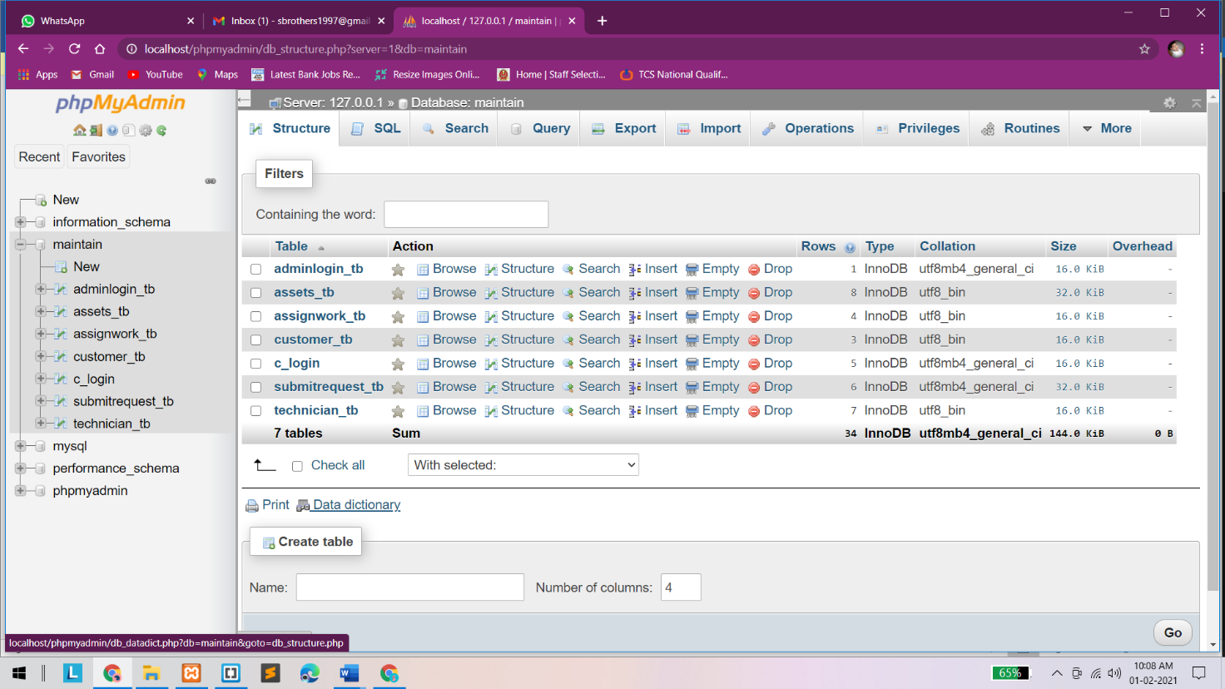

**c_login**

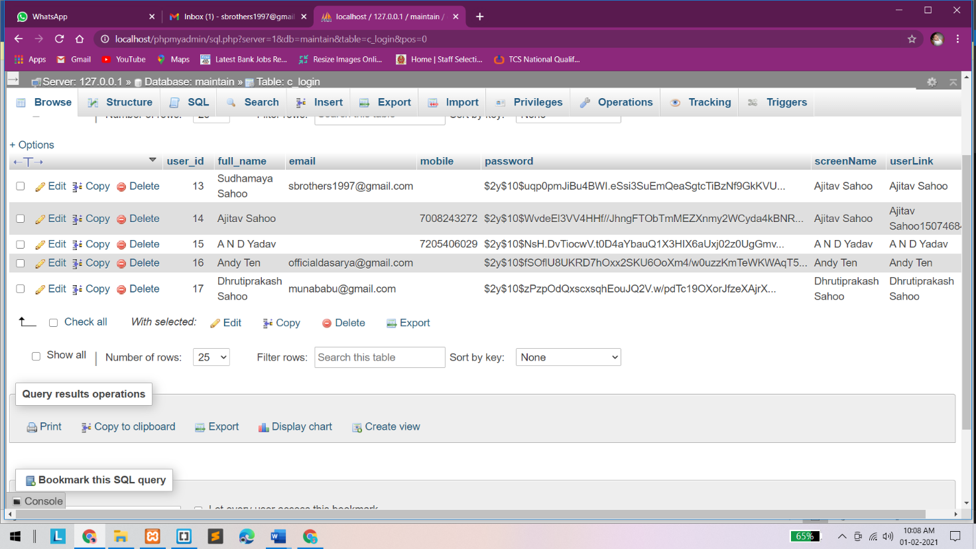

**adminlogin_tb**

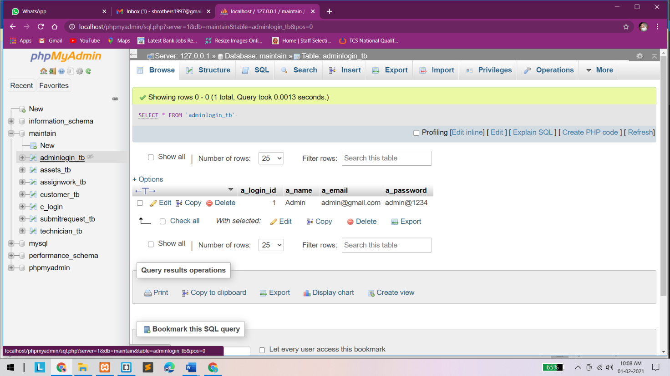

**assignwork_tb**

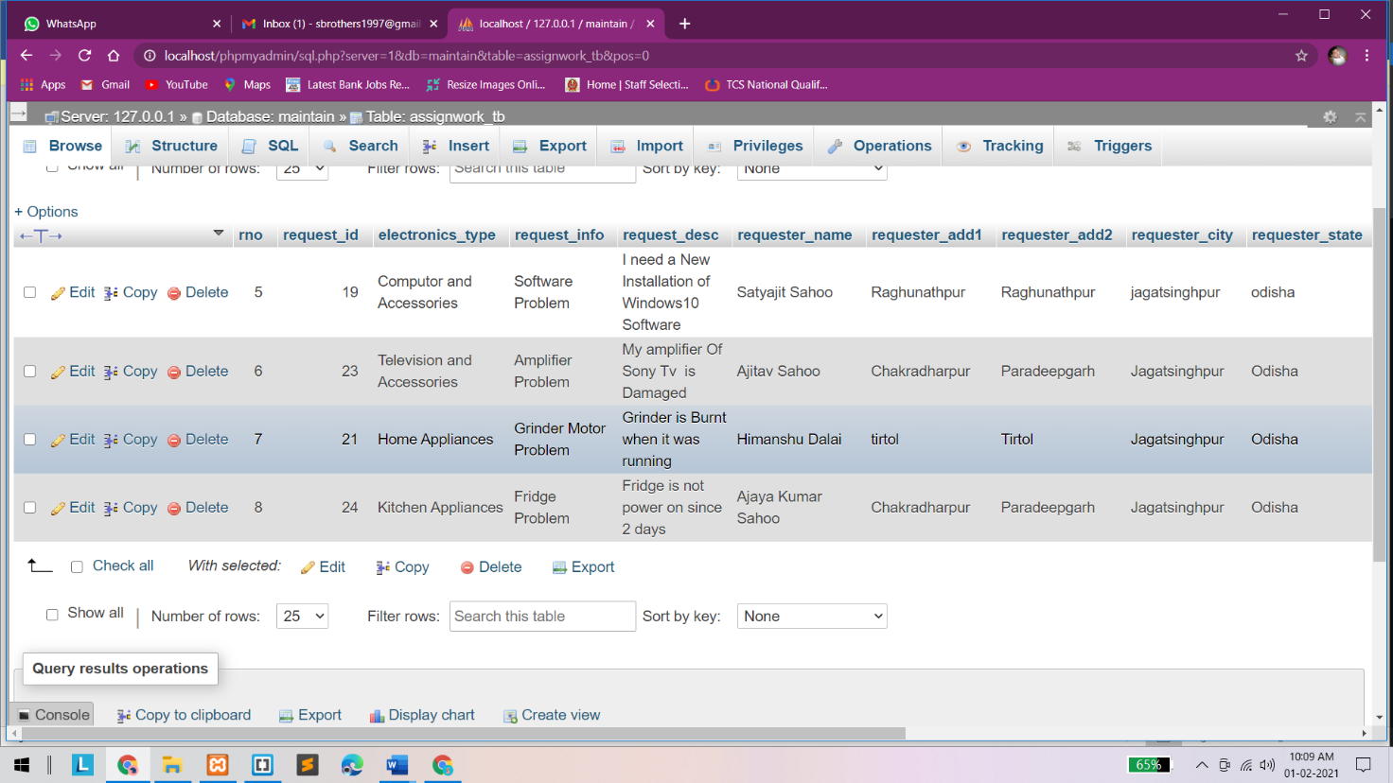

**submitrequest_tb**

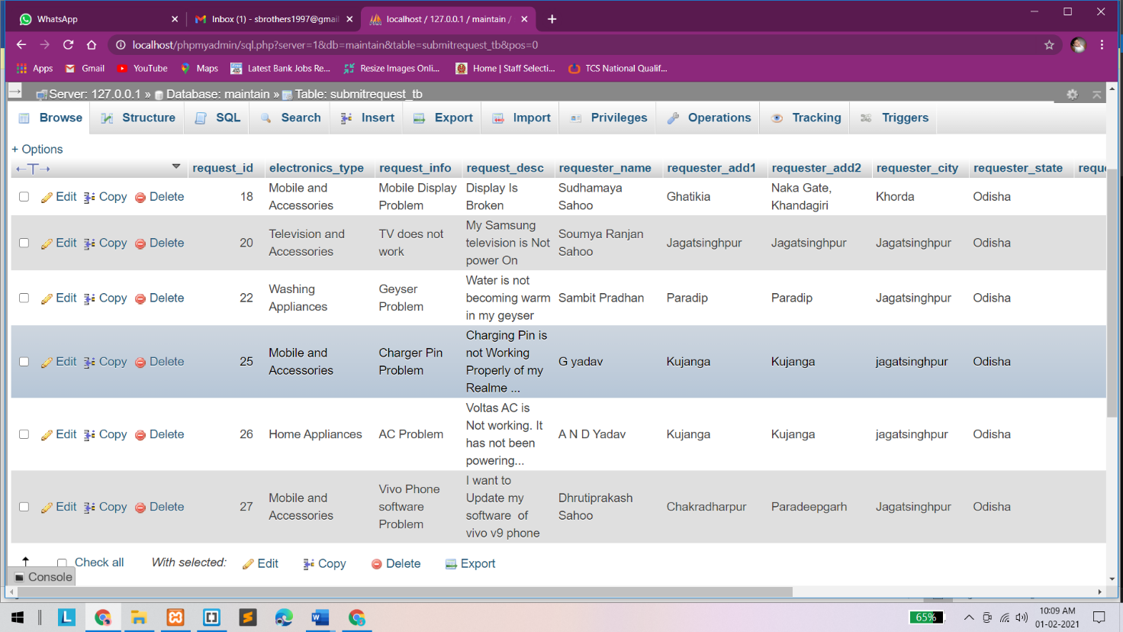

**Chapter-9:: Output Screens**

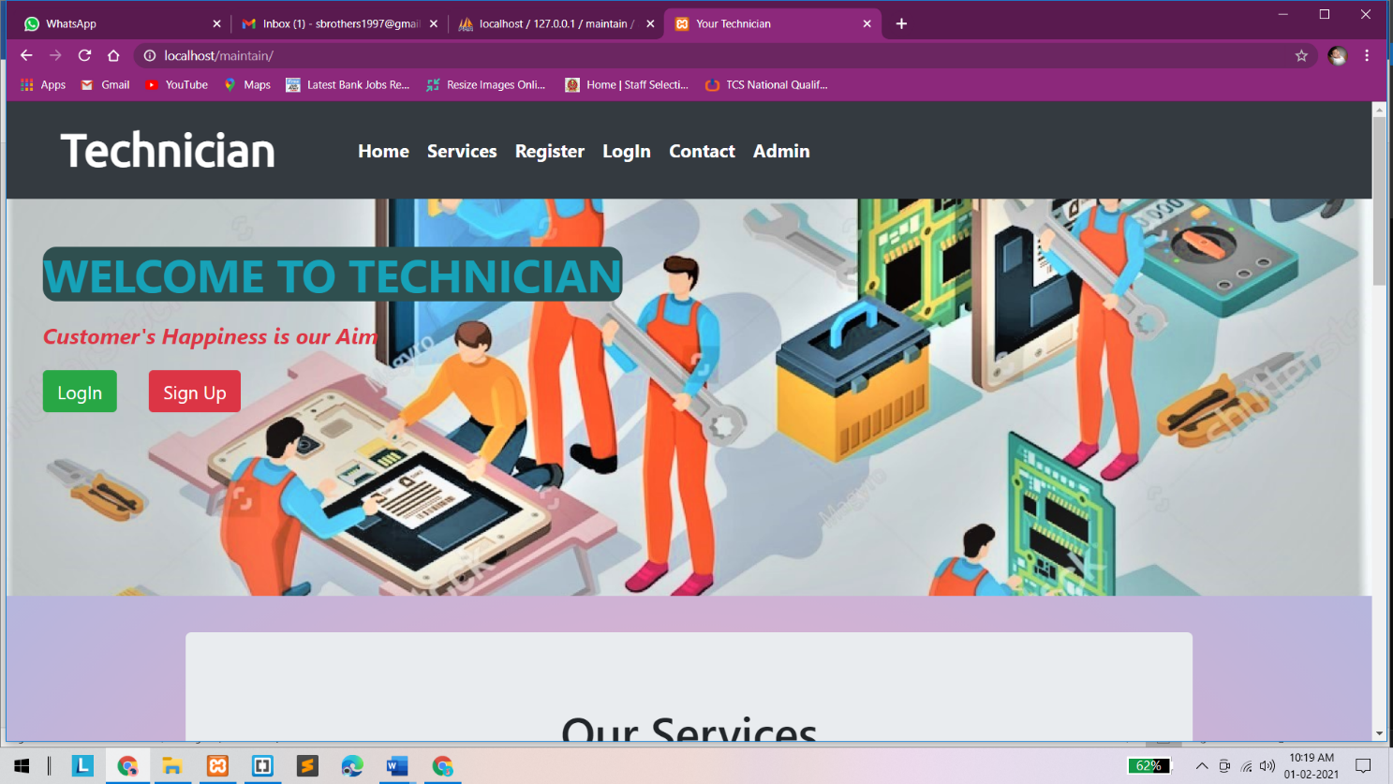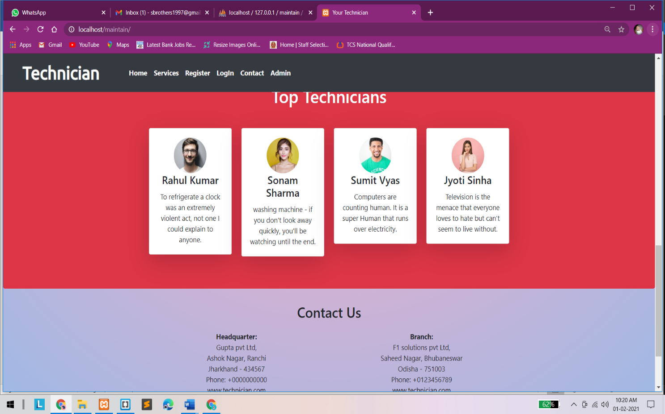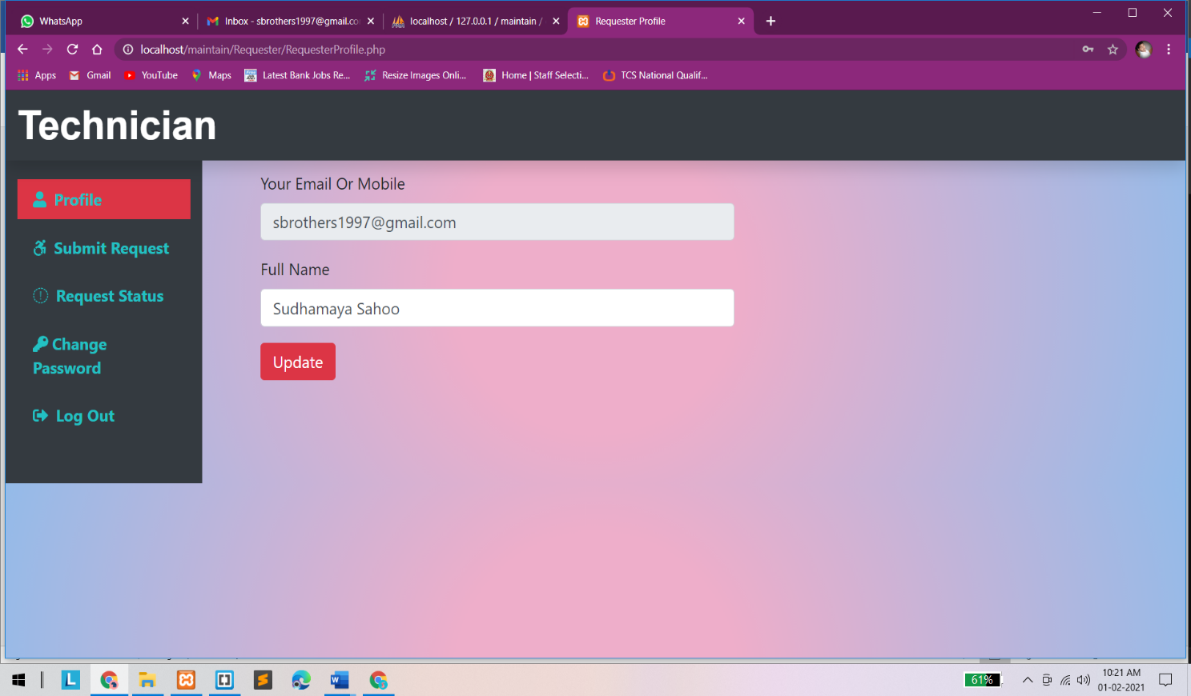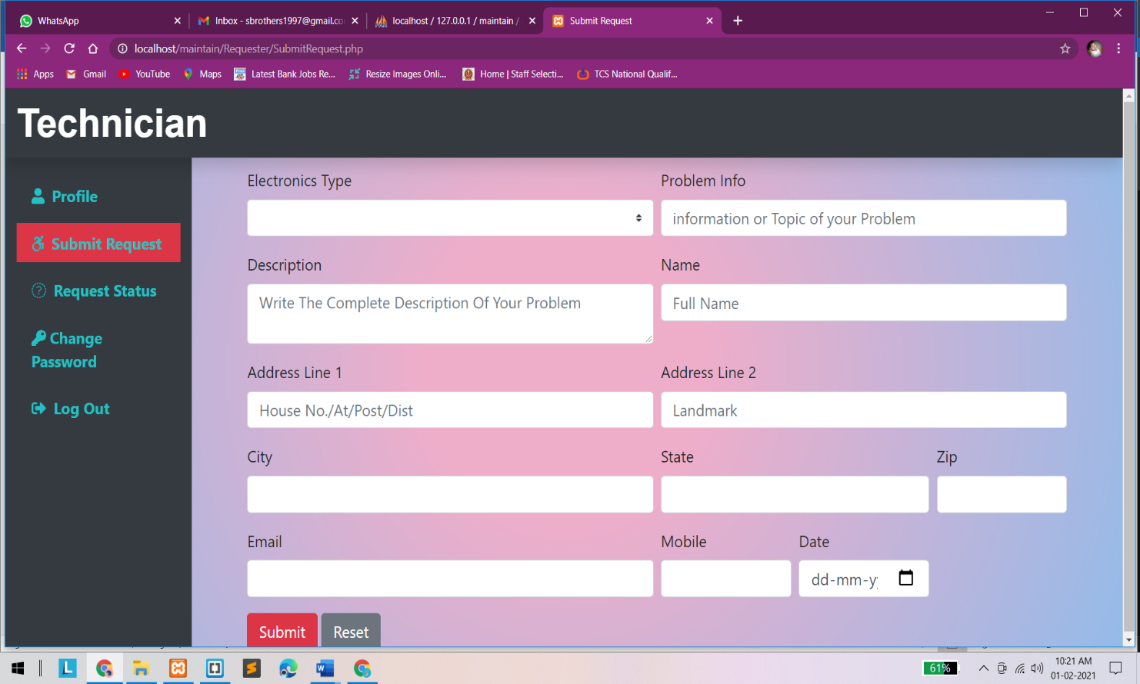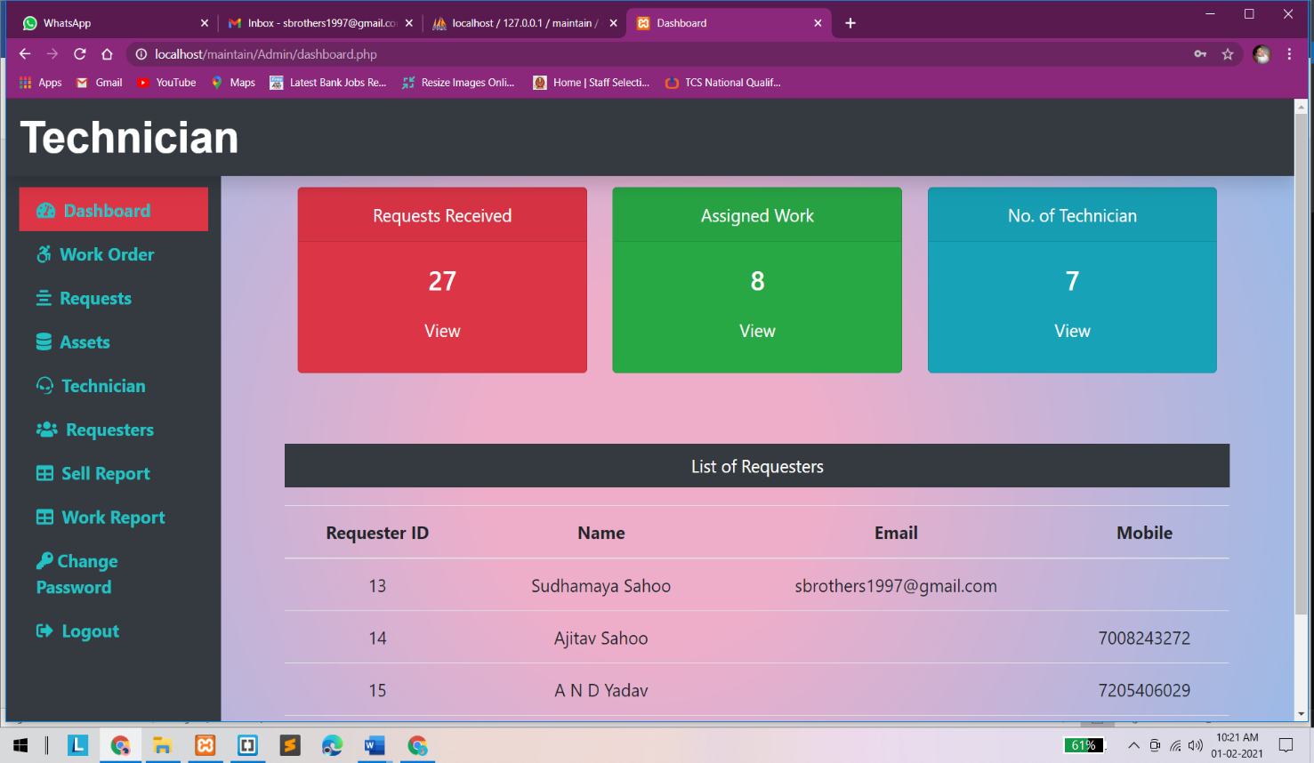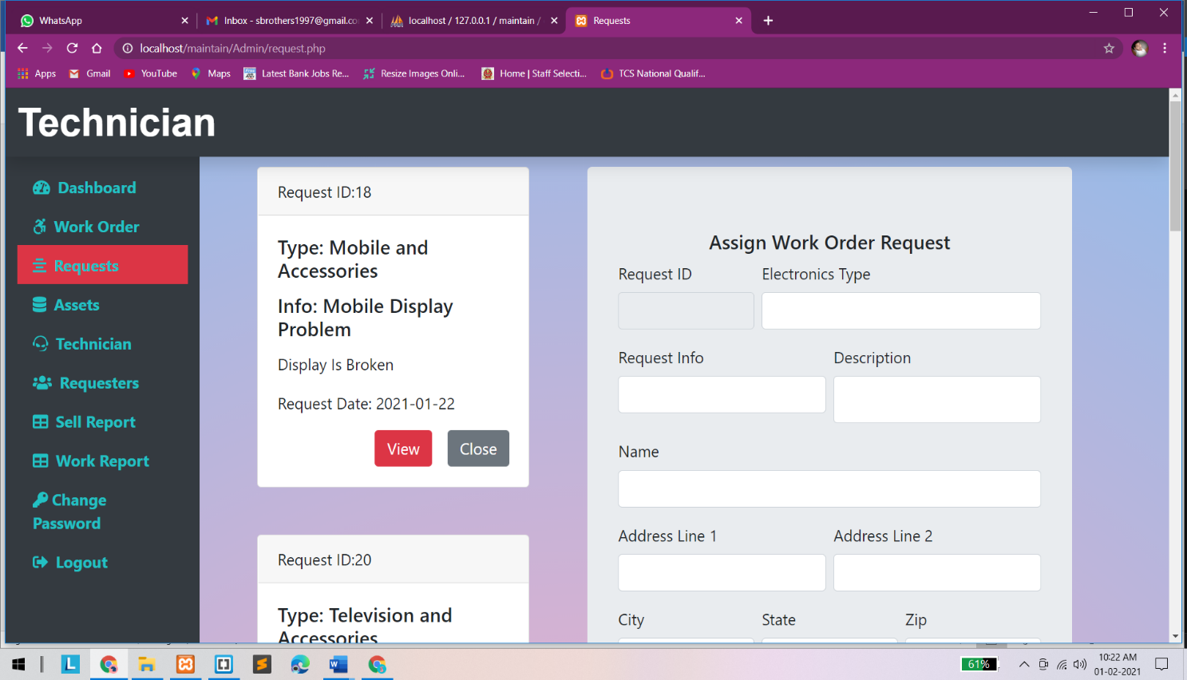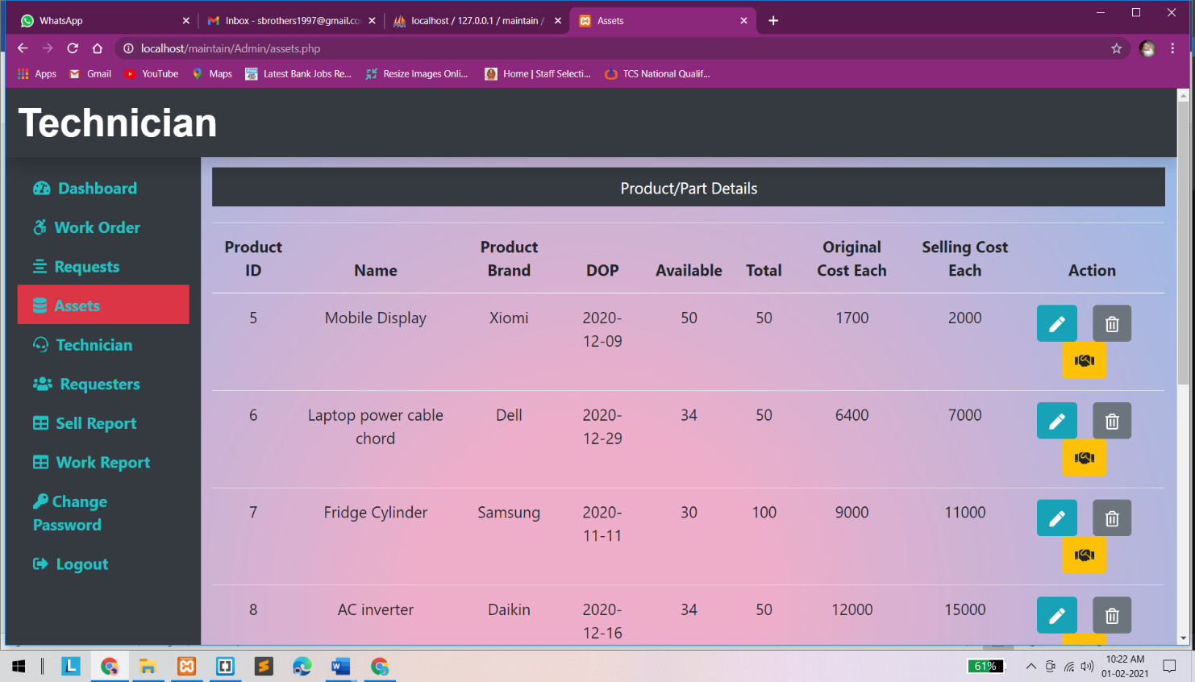

**Chapter-10:: Conclusion**

The Online Service Managment System has been computed successfully and was also tested successfully by taking "Test Cases". It is user friendly, and has required options, which can be utilized by the user to perform the desired operations.

The Software is developed using HTML, CSS, JS as front end and PHP, MySql as back end in windows environment.

The following are the Limitations of this project:

* SMS alert facility is not available.
* Portal is not SEO friendly
* Registration Email Verification Not available
* Risk unauthorized accessibility

The goals that are achieved by the software are:

* Simplification of the operations
* Less processing time and getting required information
* User friendly
* Portable and flexible for further enhancement

**Chapter-11:: References/Bibliography**

The following reference has been used to develop the project “Online Service Managment System” :-

**Books: -**

* The Complete Reference PHP
* Head First SQL: Your Brain on SQL by Lynn Beighley

**Web Source: -**

* www.w3schools.com
* www.wikipedia.org
* www.tutorialspoint.com
* www.stackoverflow.com
* www.docs.microsoft.com